

**CAPSTONE PROJECT REPORT**

**Report 6 – Software User Guides**

– Ho Chi Minh, September 2023 –

**Table of Contents**

I. Record of Changes 3

II. Release Package & User Guides 4

1. Deliverable Package 4

2. Installation Guides 4

2.1 System Requirements 4

2.2 Installation Instruction 4

3. User Manual 5

3.1 Overview 5

3.2 Workflow 1 - Initialize a Planned Conference 6

3.3 Workflow 2 - Monitor and Manage Conference Submissions 11

3.4 Workflow 3 - Prepare Conference Proceeding​ 23

# I. Record of Changes

| **Date** | **A* M, D** | **In charge** | **Change Description** |
| --- | --- | --- | --- |
|  |  |  |  |
|  |  |  |  |
|  |  |  |  |
|  |  |  |  |
|  |  |  |  |
|  |  |  |  |
|  |  |  |  |
|  |  |  |  |
|  |  |  |  |
|  |  |  |  |
|  |  |  |  |
|  |  |  |  |
|  |  |  |  |

*A - Added M - Modified D - Deleted

# II. Release Package & User Guides

## 1. Deliverable Package

| **No** | **Deliverable Item** | **Description** |
| --- | --- | --- |
| 1 | Project Schedule/Tracking | With the project schedule we use Excel in order to track the process of tasks in the project.  Link: [Project Tracking](https://docs.google.com/spreadsheets/u/2/d/18EGdvcJqmxkn4oL7Q5-4eV4KnbvsABzivdHY_yDj7Ps/edit) |
| 2 | Source Codes | With the source code, we store our code (back-end API, web application and mobile) on github with private access.  Link: <https://github.com/Capstone-Project-Backend-DTHNA> |
| 3 | Database Script(s) | [SRASS_Script](https://drive.google.com/file/d/1I1Lc98EurhpDgQxfulo_ofytg6ayqK2M/view?usp=sharing) |
| 4 | Final Report Document | [Report7_Final Project Report](https://docs.google.com/document/d/1VQUtO4SOHORIydqwrCqreHp8o4z_vL3R/edit?usp=drive_link&ouid=102107863591186936386&rtpof=true&sd=true) |
| 5 | Test Cases Document | [SU23SE08_Test_Report](https://docs.google.com/spreadsheets/d/1Svu2Q5SwTIihnr72wDTPoKEkbzP3I3Ok/edit?fbclid=IwAR2ceN8SFIZtAIVepwokBmrb9WA-PlszkyrHUsIZlCoqS-ciXmWj-OsquXs#gid=1926235940) |
| 6 | Slide | [Capstone Presentation](https://fptuniversity-my.sharepoint.com/:p:/g/personal/anhndtse150640_fpt_edu_vn/ER7N5F1dp4JPgpmUire4GOIBtvjkoC7zbHu58BL9PwyluQ?e=7T29SO) |

## 2. Installation Guides

### 2.1 System Requirements

#### 2.1.1 Hardware requirements

**Web Application:**

| **Laptop** | **Minimum Requirements** | **Recommended** |
| --- | --- | --- |
| Internet Connection | Wi-Fi (4 Mbps) | Cable, Wi-Fi (8 Mbps) |
| Operating System | Windows 7 | Windows 10 |
| Computer Processor | Intel® Core i3 1.4GHz | Intel® Core i5 2.50GHz |
| Computer Memory | 2GB RAM | 2GB RAM or more |
| Web Browser | Chrome (v69 or higher) | Chrome latest stable version |

#### 2.1.2 Software requirements

| **Software** | **Name / Version** | **Description** |
| --- | --- | --- |
| Operation System | Windows 10 / 11 | Operating system and platform for development |
| Web browser | Chrome v69 or above | For web app |

### 2.2 Installation Instruction

#### 2.2.1 Back-end

1. Install Visual Studio 2019 IDEA by following guidelines link: <https://visualstudio.microsoft.com/downloads/>
2. Install Visual Studio 2019 by following guidelines link: <https://learn.microsoft.com/en-us/visualstudio/install/install-visual-studio?view=vs-2022>
3. Clone source code from GitHub by link: <https://github.com/ThuongHoang456189/Sras.PublicCoreflow>
4. Open solution with Visual Studio 2019
5. In Visual Studio, click run without debug

#### 2.2.2 Web app

1. Install Visual Studio Code by following guidelines link: <https://code.visualstudio.com/download>
2. Install npm through Visual Studio Code or you can install npm via NodeJS (should download Nodejs v18 above)  
   <https://nodejs.org/en>
3. Install yarn after installing npm. Run command: “npm install --global yarn"
4. Set up Firebase **Storage** project:  
   <https://console.firebase.google.com/u/0/>
5. Login PayPal then get Client ID:   
   <https://developer.paypal.com/dashboard/applications/live>
6. Clone source code from GitHub by link:   
   <https://github.com/Hien-BT01/capstone-client>
7. Create “**.env.local**” file. Move all content in “**.env.example**” to “**.env.local**” and replace the value with correct information corresponding key.
8. Open folder project by Visual Studio Code.
9. Open terminal and enter **yarn**
10. In terminal, enter **yarn start**
11. Project start with <http://localhost:3000>

## 3. User Manual

### 3.1 Overview

The project has 3 main workflows below:

**1. Initialize a planned conference:**

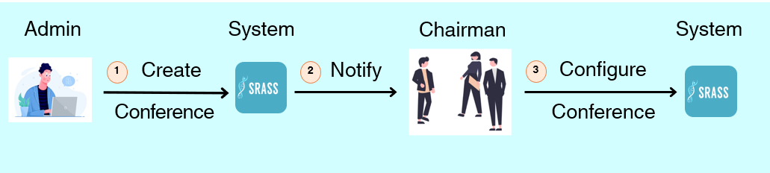

**2.** **Monitor and manage conference submissions:**

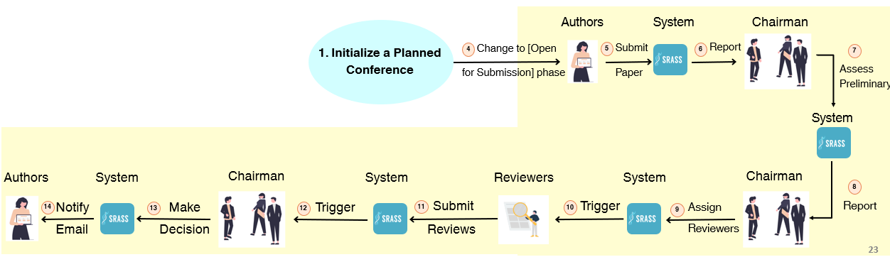

**3.** **Prepare conference proceeding:**

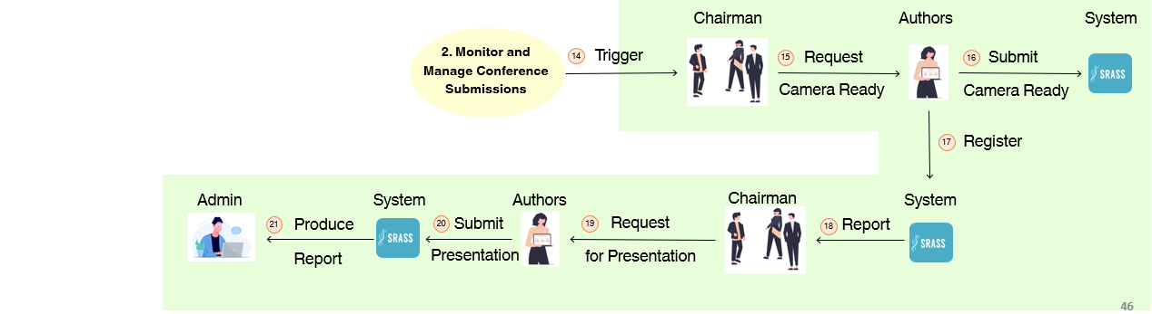

**4**. **Other:**

* Conference website creation
* Lecture research profile

### 3.2 Workflow 1 - Initialize a Planned Conference

#### 3.2.1 <Admin> Create Conference

Logging into system as “Admin” role, to create conference, Admin clicks on “CREATE CONFERENCE” button

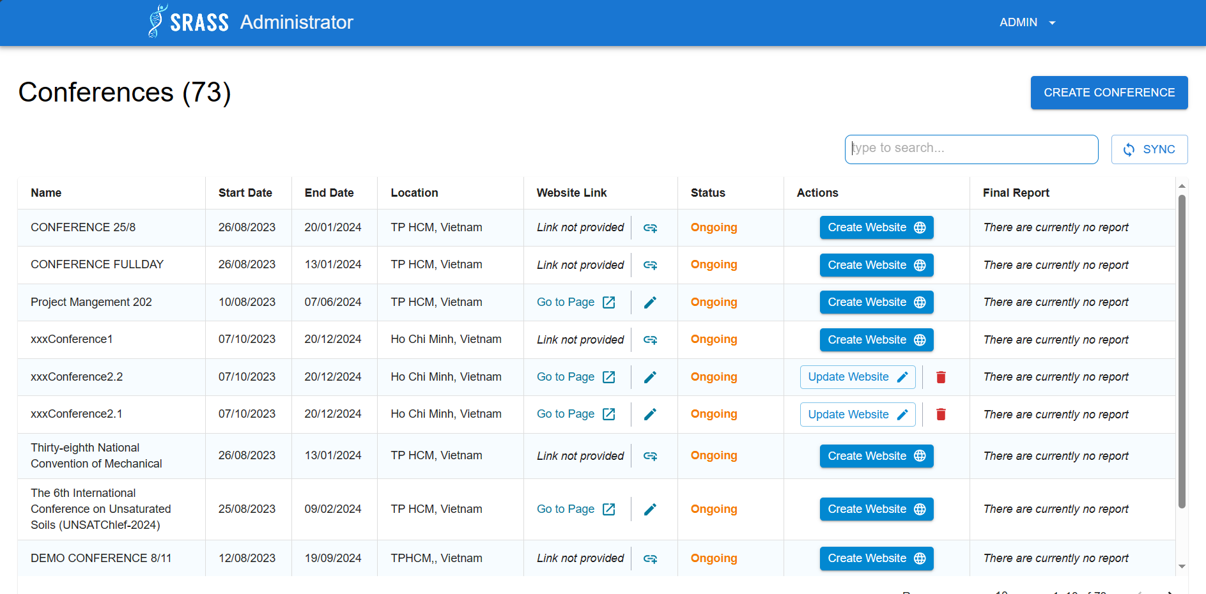

Admin fulfil all required information then click on ”+ CREATE CONFERENCE” to finishing creating conference

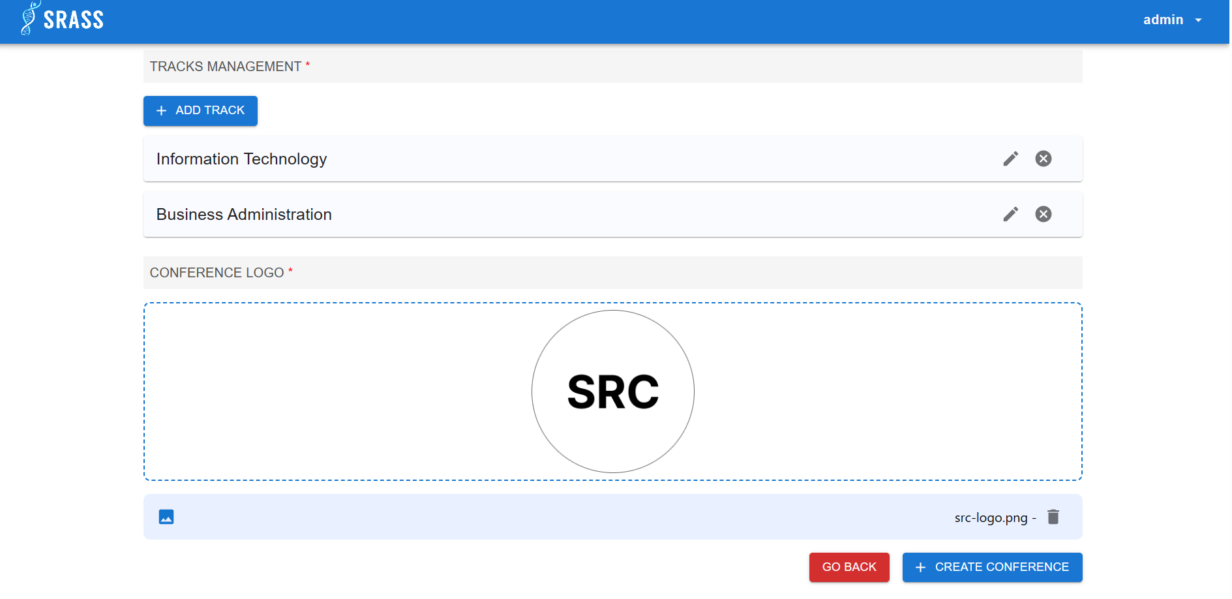

#### 3.2.2<Unauthenticated User> Login

To login into the system, users enter their email and password, then click on “Login: button.

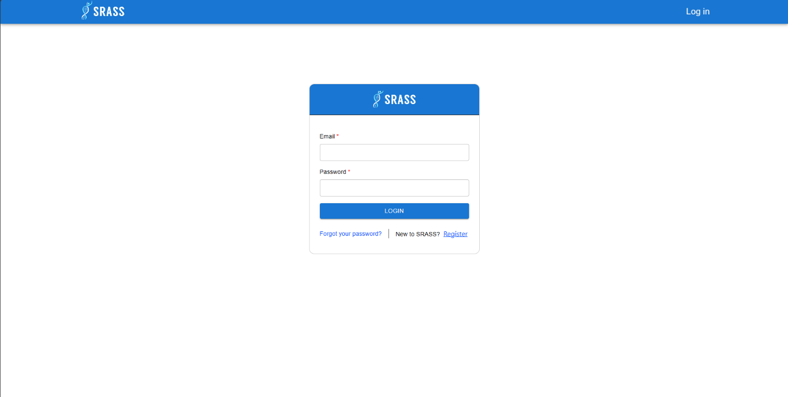

After logging successfully, authenticated user will see the Conferences Screen on web application. There has three tabs, the default one is “MY CONFERENCES”.

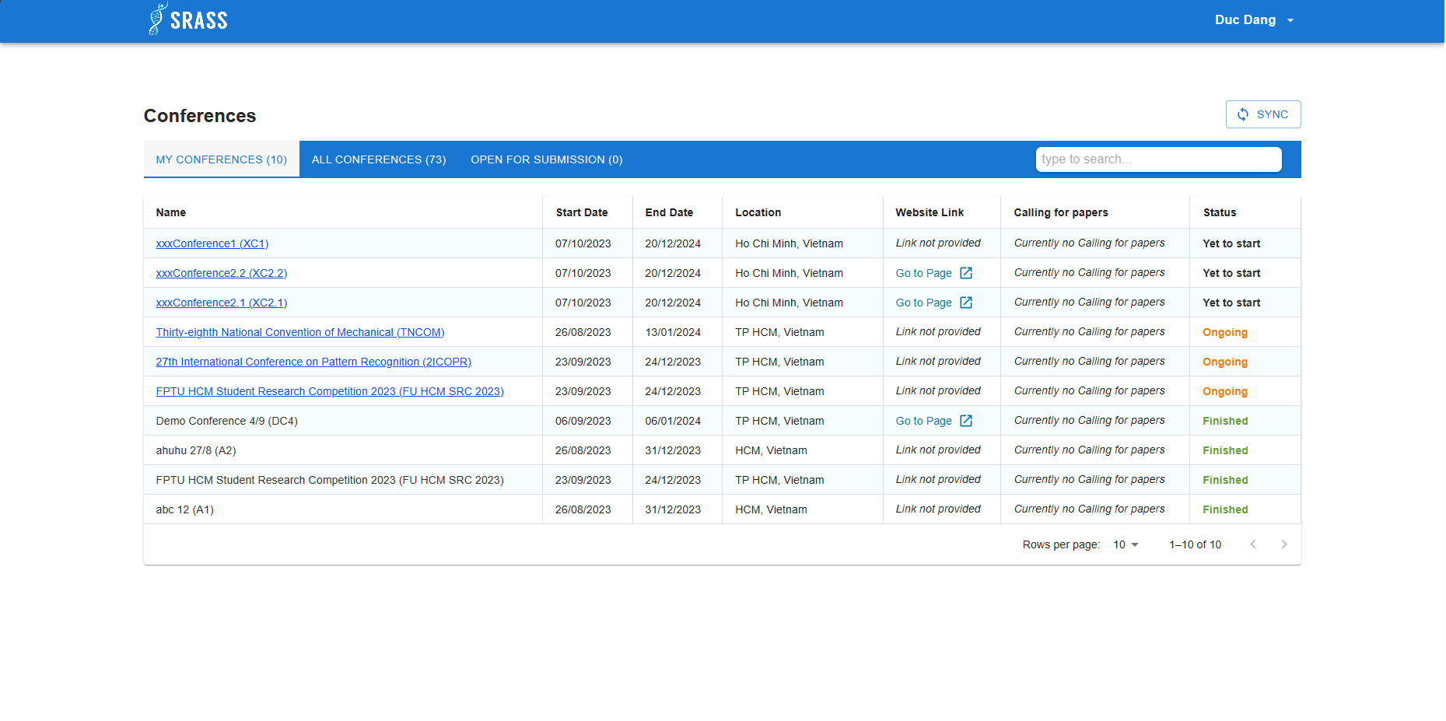

#### 3.2.3 <PC Chair> Create Track Planning

PC Chair choose the conferences. because the conference is in its early stages, so the first task for PC Chair is creating “track planning” for selected track.

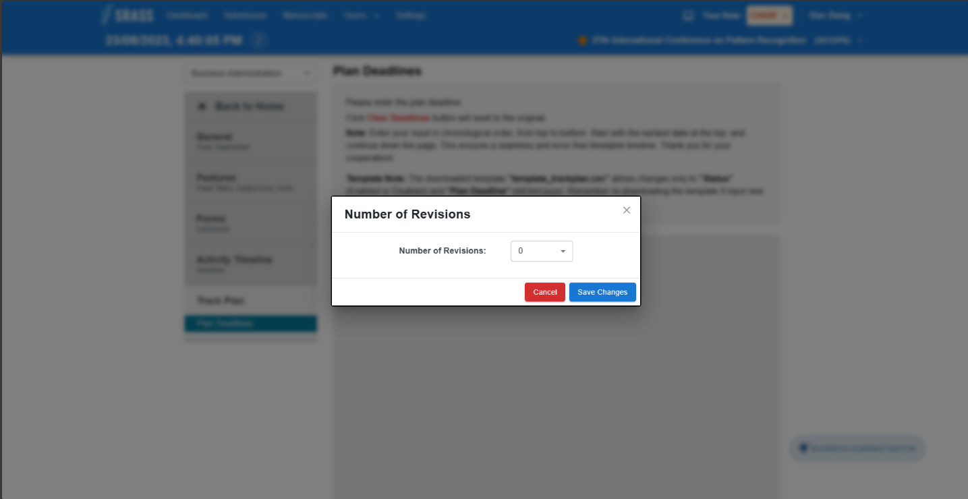 PC Chair choose number of revisions then click on "Save Changes” button to save the information. The system will create phases depending on chosen number of revisions. PC Chair must declare deadlines for phases corresponding to each phase followed by the note above. Finally, PC Chair click on ”Save Changes” button to save the track planning.

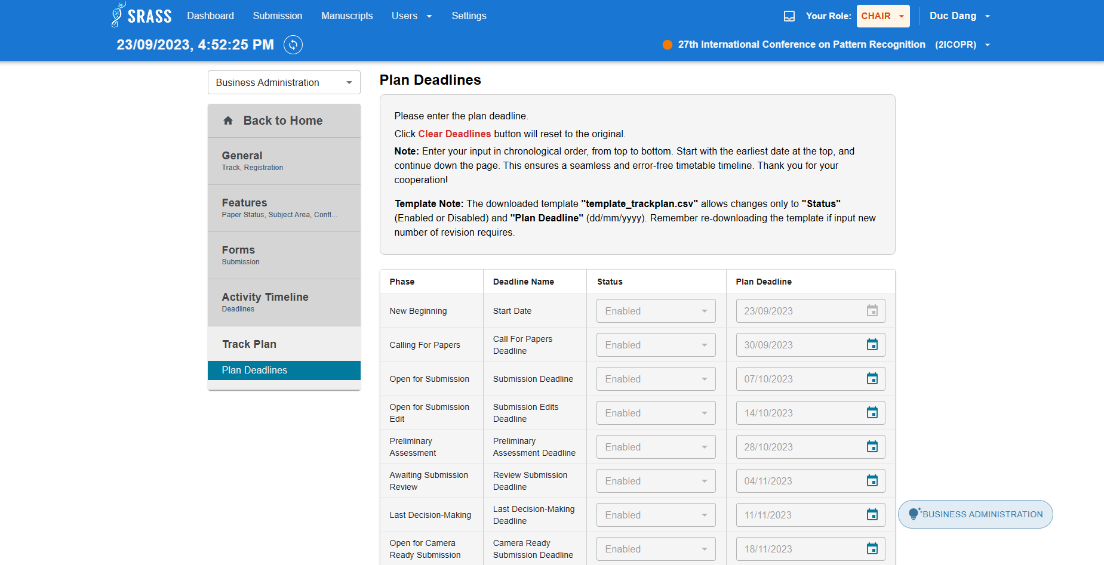   
 ***3.2.4 <PC Chair> Add PC Chair to Conference.***

This screen is for PC Chair to manage conference. PC Chair click on “Action” buttons, a dropdown will appear. Then choose “Add user to conference” to add other PC Chairs.

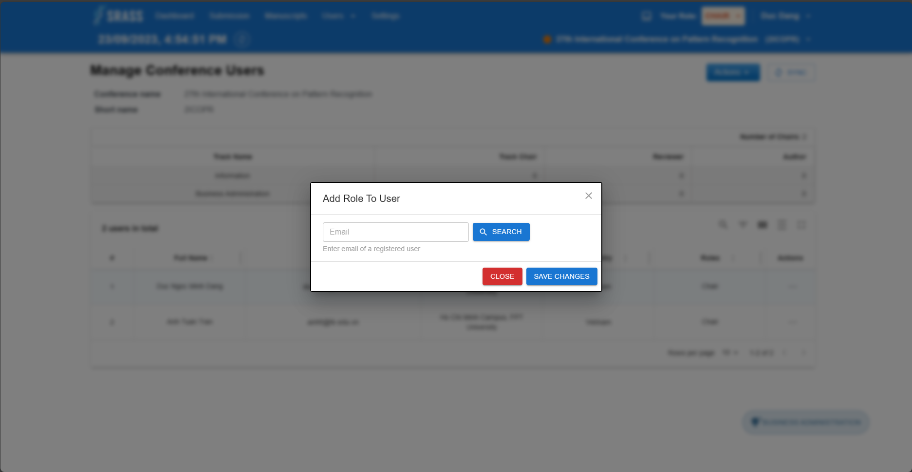

Search user by emails, then click on “Save Changes” button to add PC Chair.

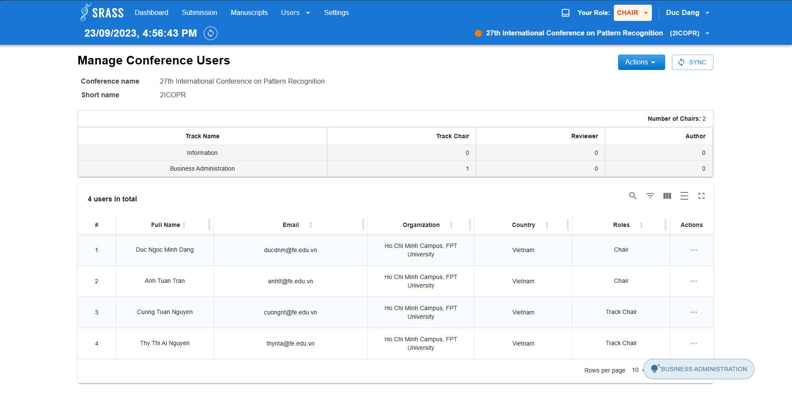

#### 3.2.5 <PC Chair> Configure Subject Area.

Conference has moved to “Calling for paper”. PC Chair must configure subject area for selected track.

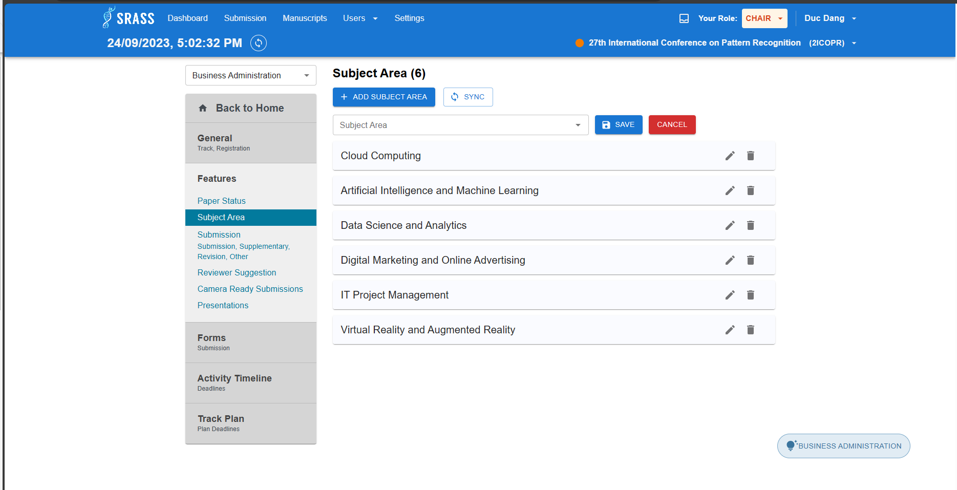 PC Chair click on “+ ADD SUBJECT AREA” to add new subject.

#### 3.2.6 <PC Chair> Configure Submission Questions.

PC Chair move to “Forms” section then choose “Submission” tab to create submission question. To Create Question, PC Chair clicks on “+ ADD NEW QUESTION” button and fulfil required information.

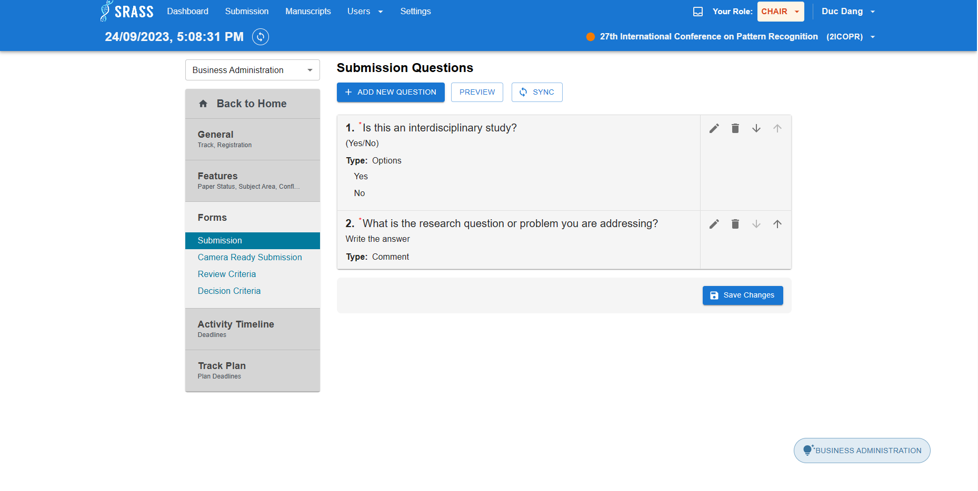 PC Chair can configure other things by move to each tab at each section.

### 3.3 Workflow 2 - Monitor and Manage Conference Submissions

#### 3.3.1 <Author> Create Submission

Login to system as “Author”, then click on “OPEN FOR SUBMISSION” tab at screen “Conferences” to redirect to “Create New Paper” page.

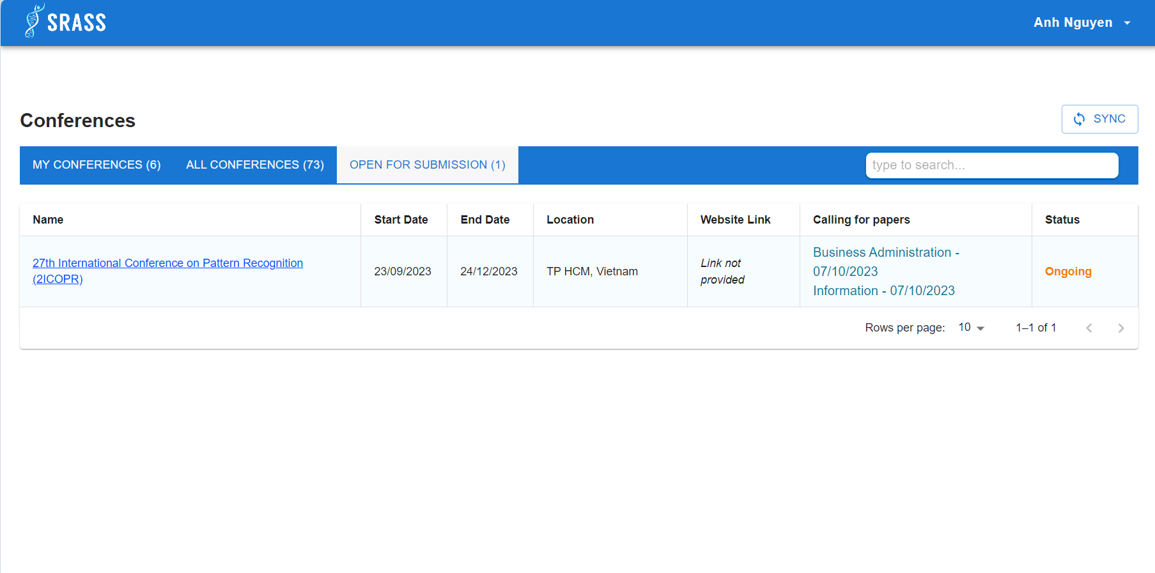 Author fulfils required information then click ”+ Submit Paper” to create submission.

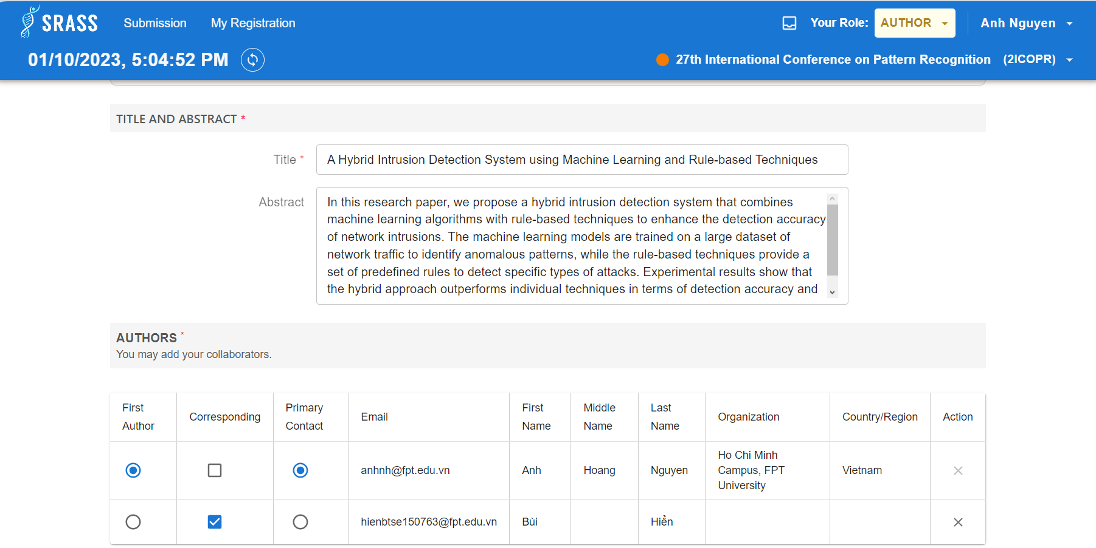

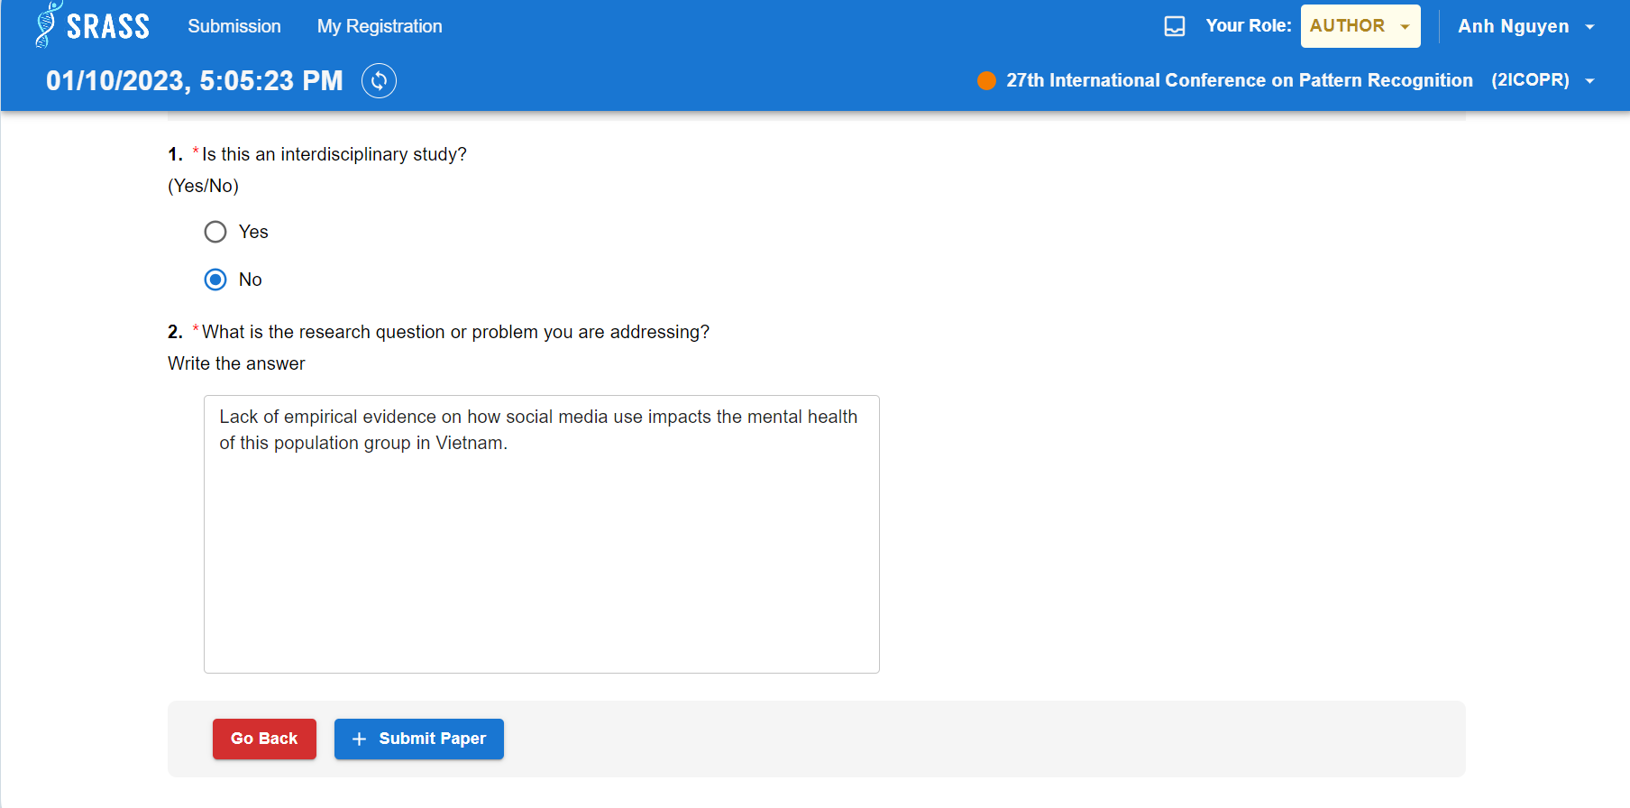 After creating submission, author can view summary information.

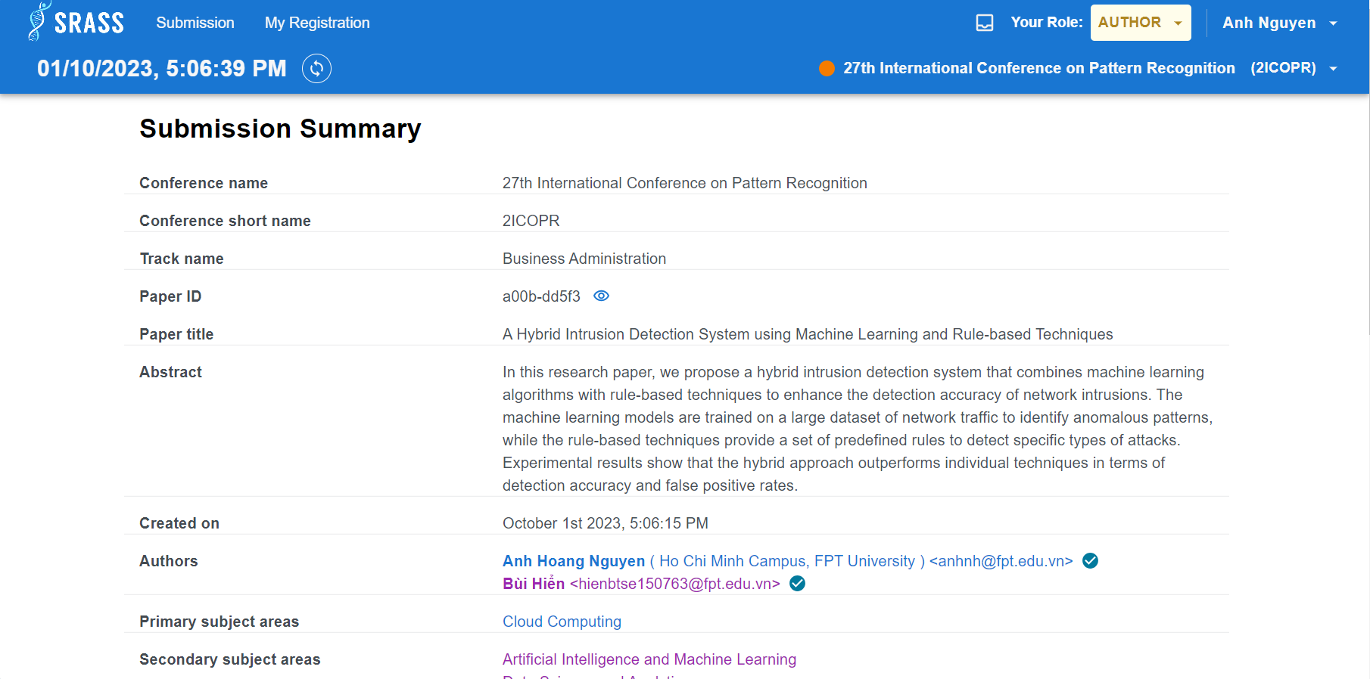 ***3.3.2 <PC Chair> Monitor Submisisons***

PC Chair can monitor the statistic of submissions and list of submissions through ” Submission Console” page.

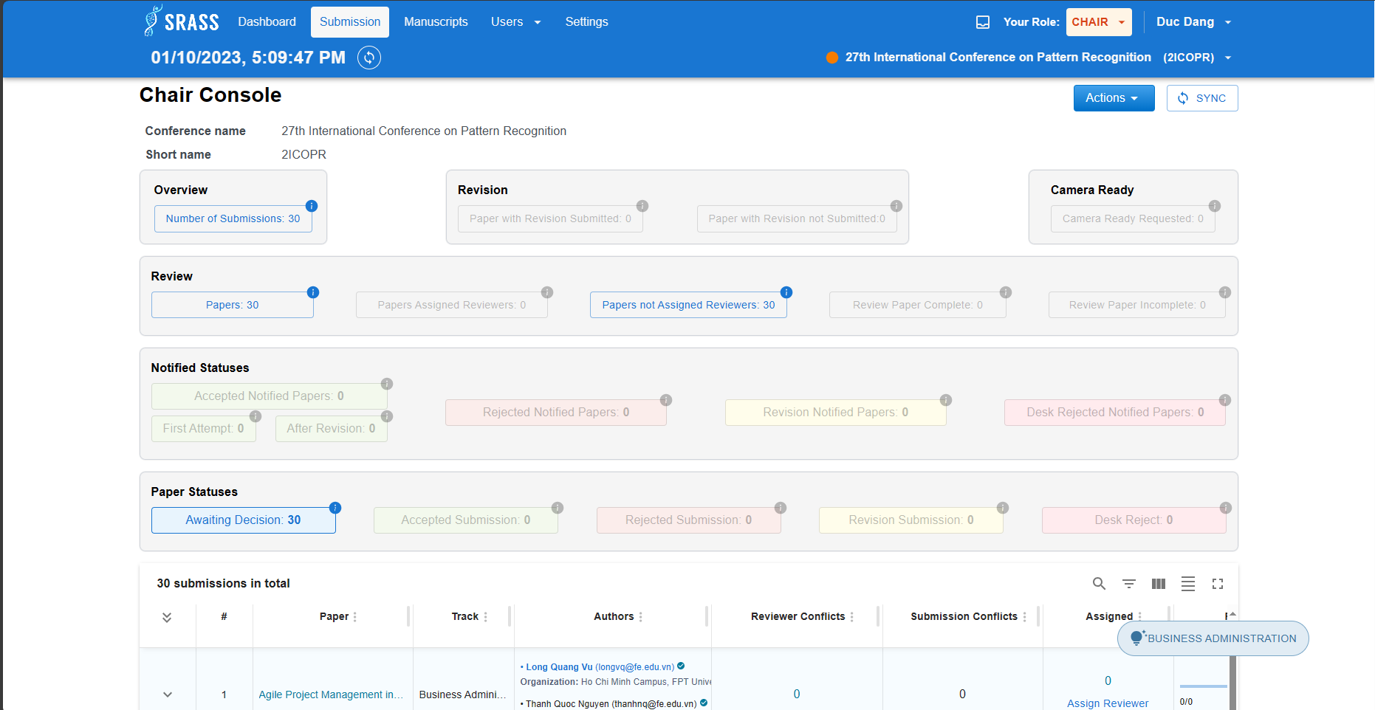 The PC Chair relies on the number of submissions to estimate the number of reviewers to add to the conference. To add Reviewer, PC Chair goes to ” Manage Conference Users”, click on ” Actions” then choose ” Add user to conference” and search by email.

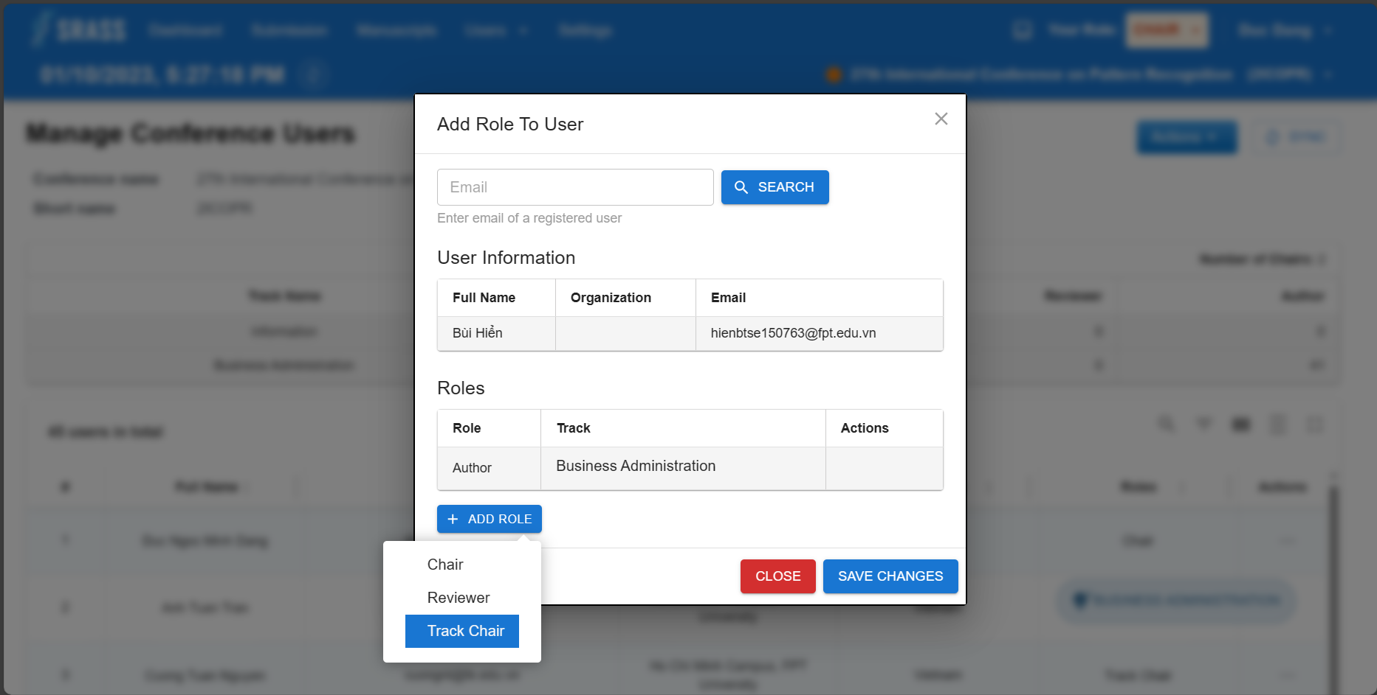 PC Chair can view overall number of submissions, authors, reviewers, users in conference and view statistic of each track by clicking on ”Dashboard” on header, then choose ”Participation” tab.

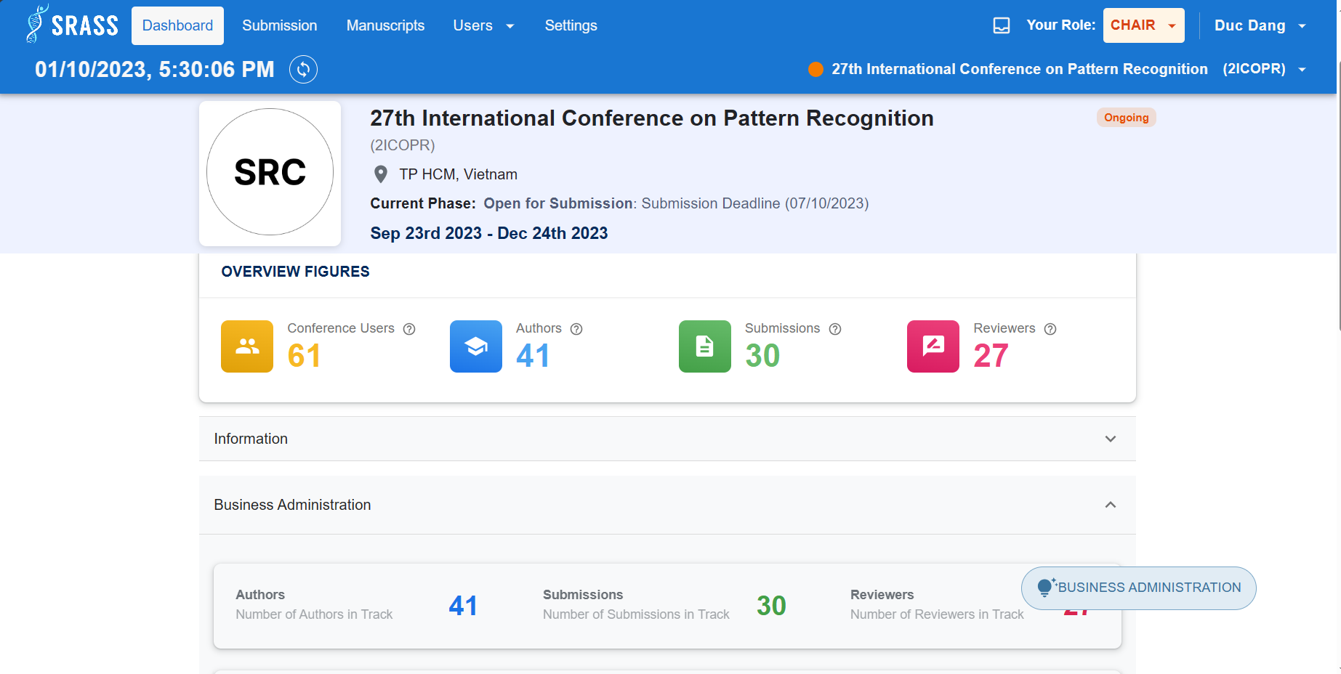

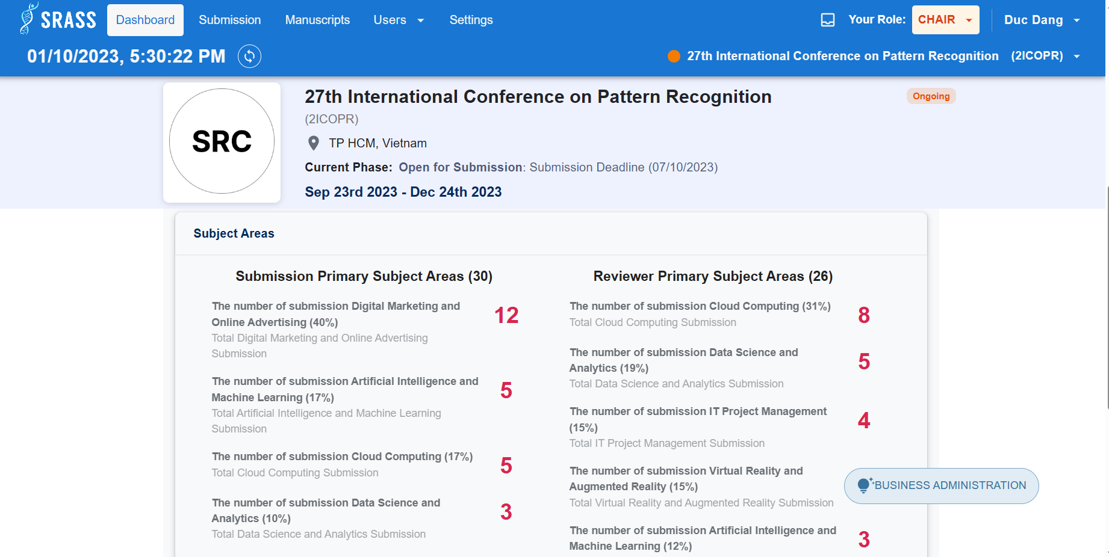 ***3.3.3 <Author> Edit Submission***

Conference move to “Open Edit Submission”. Author now can edit their submission. For example, edit conflict interest for submission. Author click on “Edit Conflicts” button.

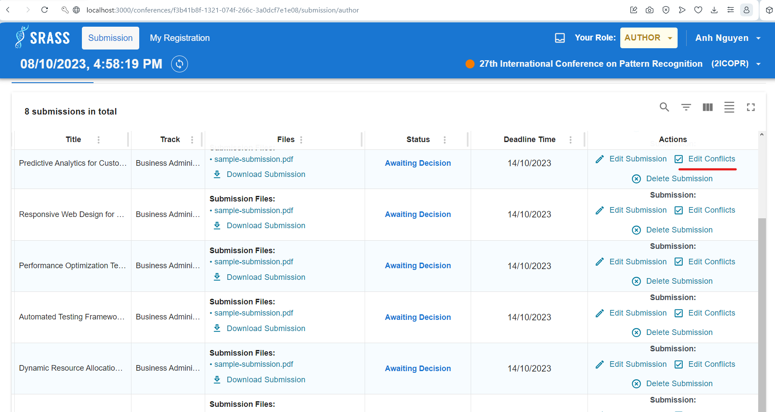 Choose reviewer with selected conflict then click on ”Save Changes” button.

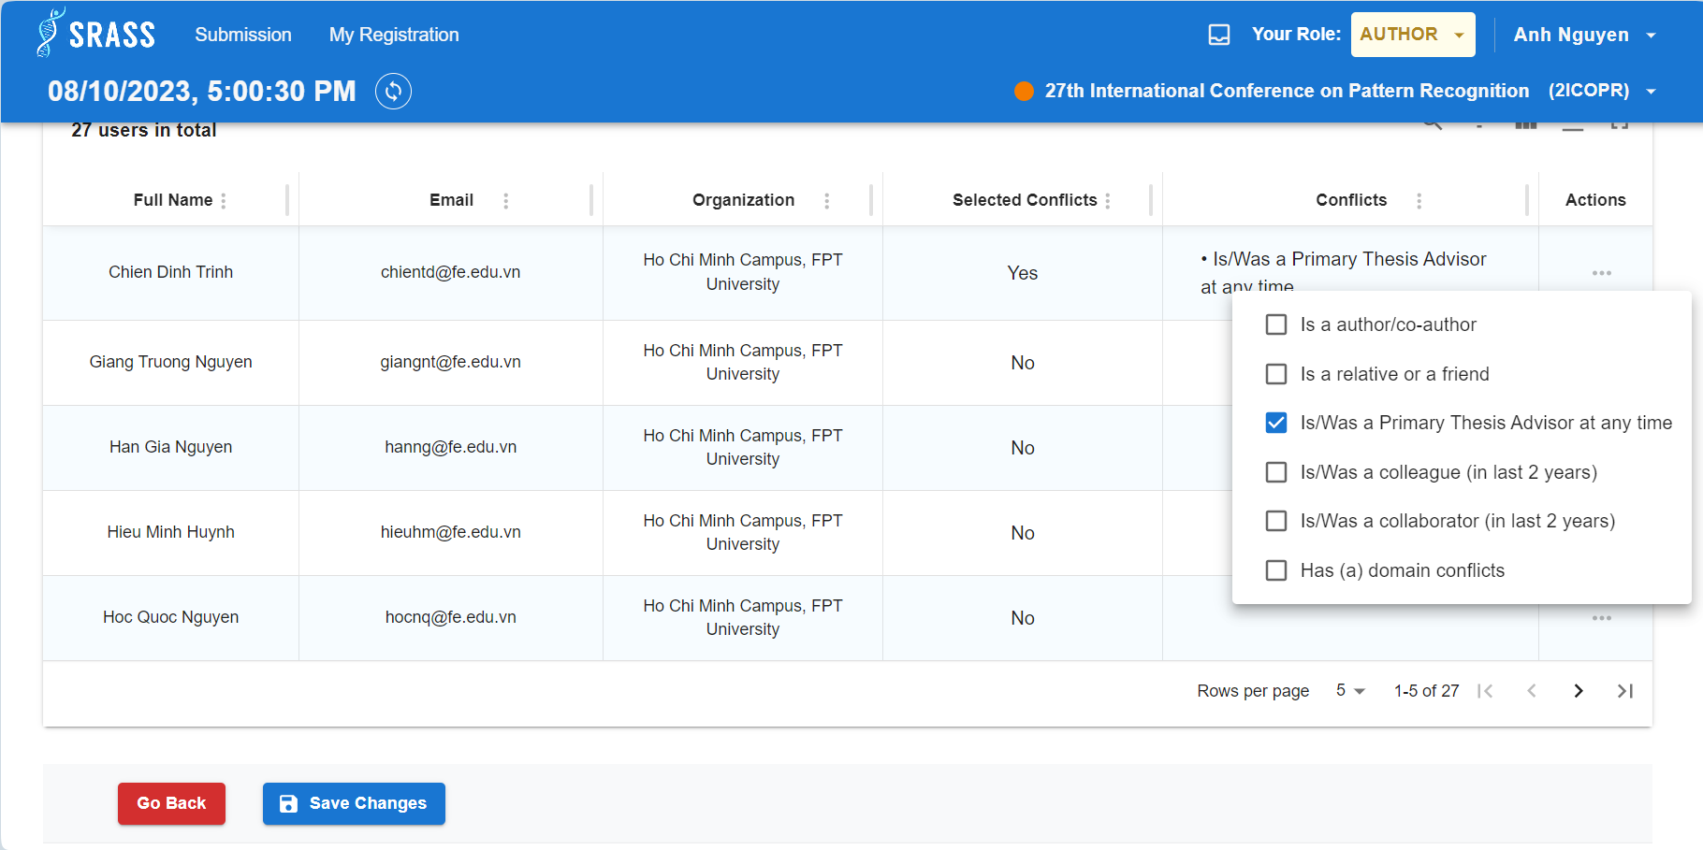

#### 3.3.4 <PC Chair> Desk Reject Submissions

The current phase of the conference is “Desk Reject”. PC Chair click on “Desk Reject” button of specific submission to desk rejected, PC Chair also can view the number of submissions desk rejected at “Submission Console” page.

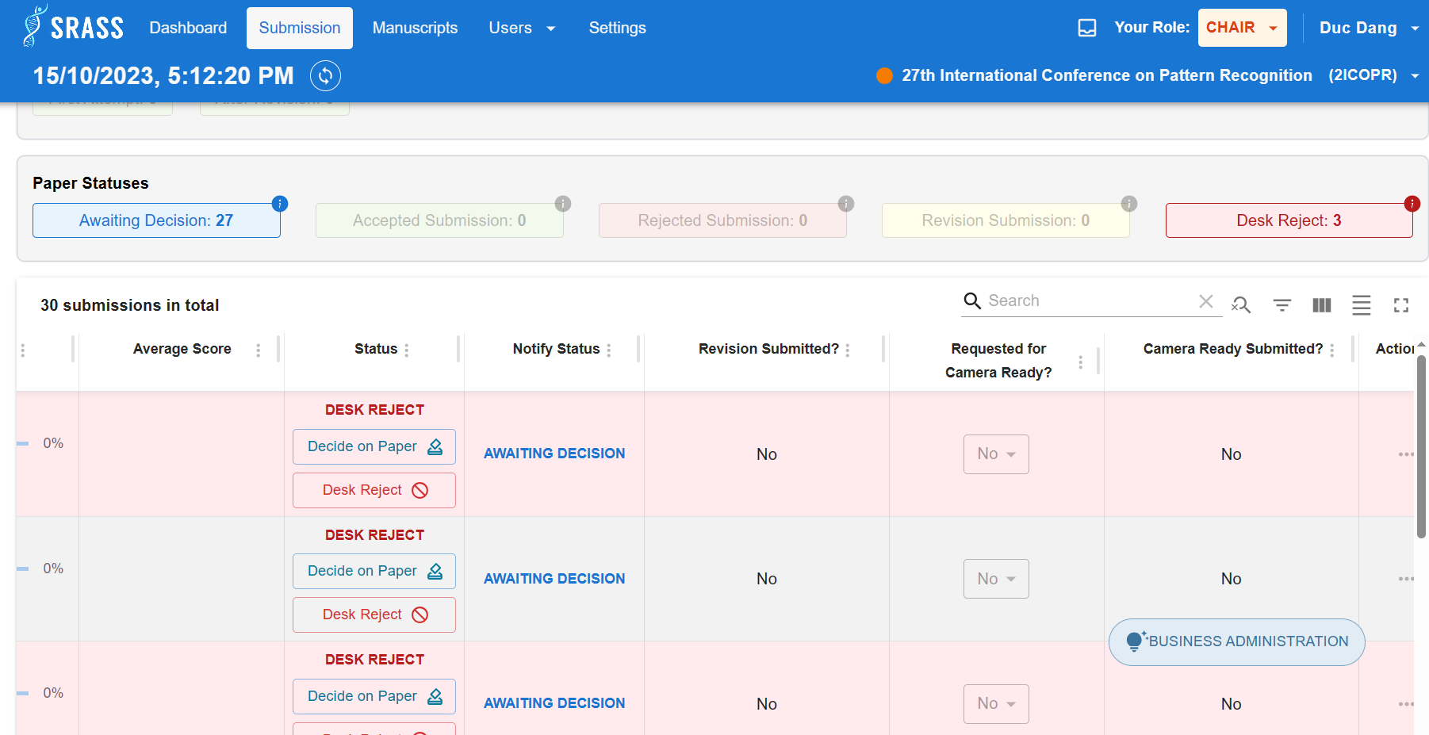 ***3.3.5 <PC Chair> Assign Reviewers To Submission***

By clicking on “Actions” button at specific submission, PC Chair choose “Edit Reviewer Assignments” to assign reviewer to submission.

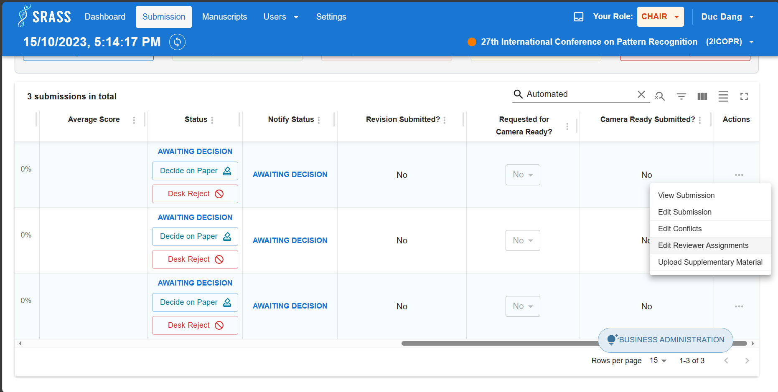 At ”Reviewer Assignment Console” page, PC Chair choose reviewers then click on ”Assign” button to assign.

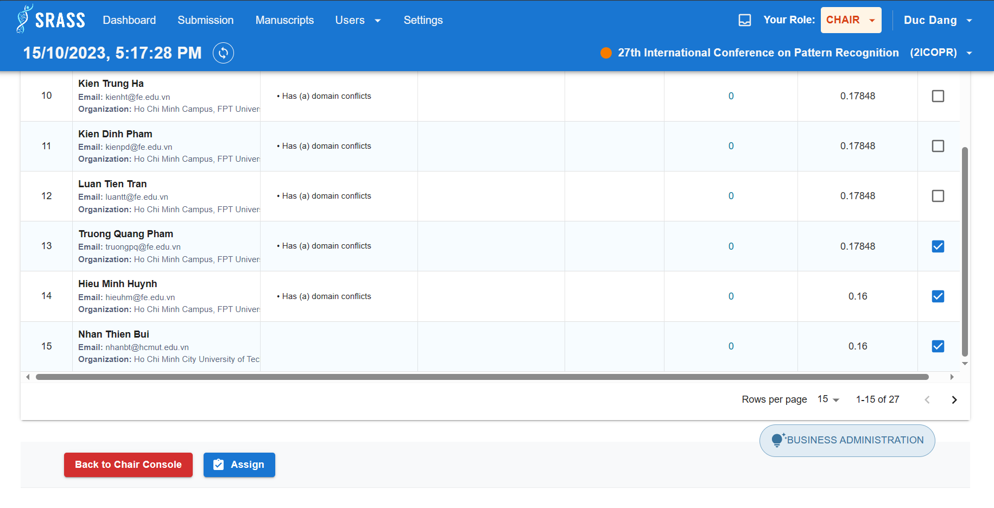

After assigning Reviewers, PC Chair can monitor statistic related to reviewer assignments.

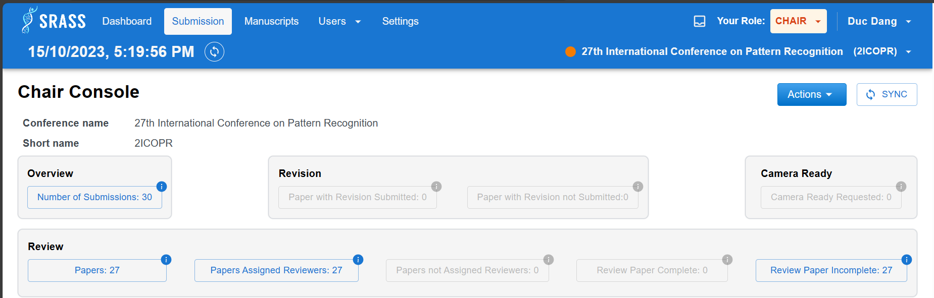

#### 3.3.6 <Reviewer> Reviewer Review Submission

The current phase of the conference is “Awaiting Submission Review”. To review submission, Reviewer click on “Enter Review” button at “Actions” column.

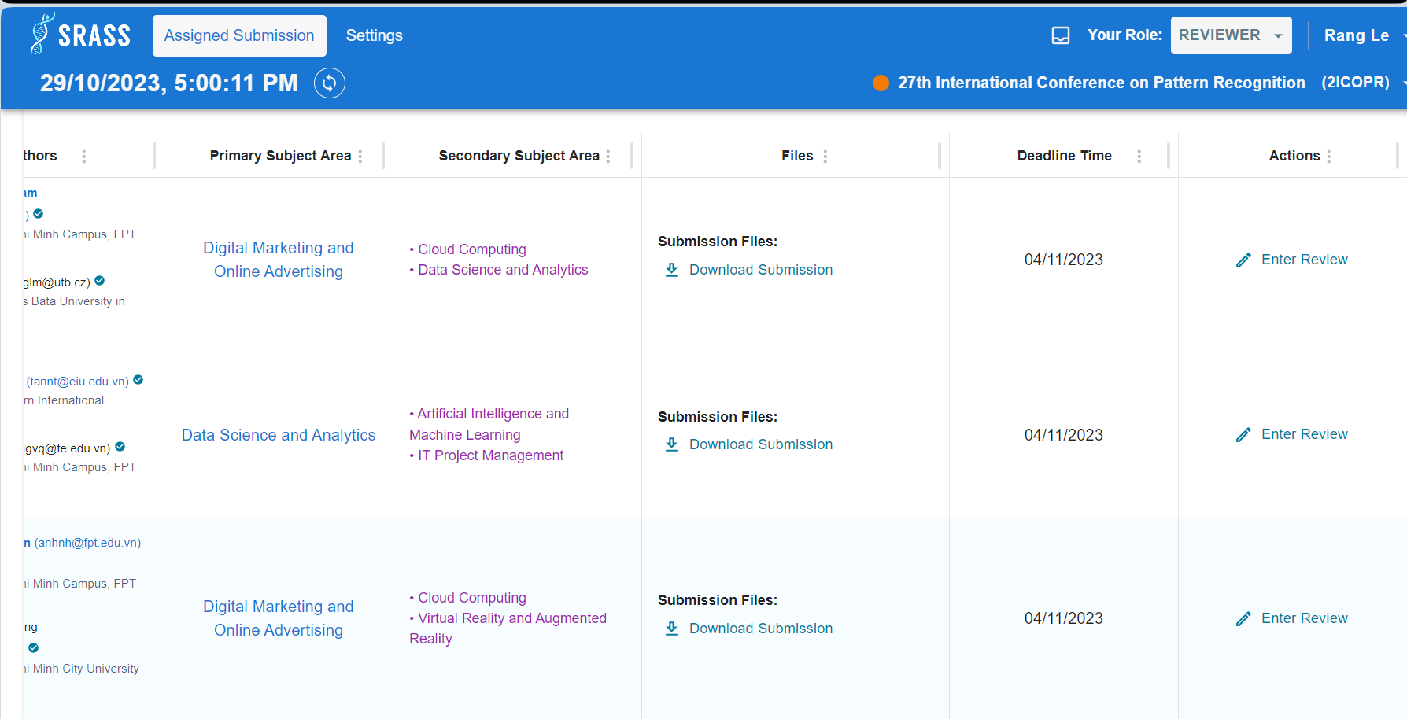

Reviewer enters necessary information, then click “Submit Review” button to finish review a submission.

#### 3.3.7 <PC Chair> Decide On Submission.

After the “Awaiting Submission Review” ended. Now the phase is “Last Decision-Making", PC Chair can decide on paper by clicking “Decide on Paper”.

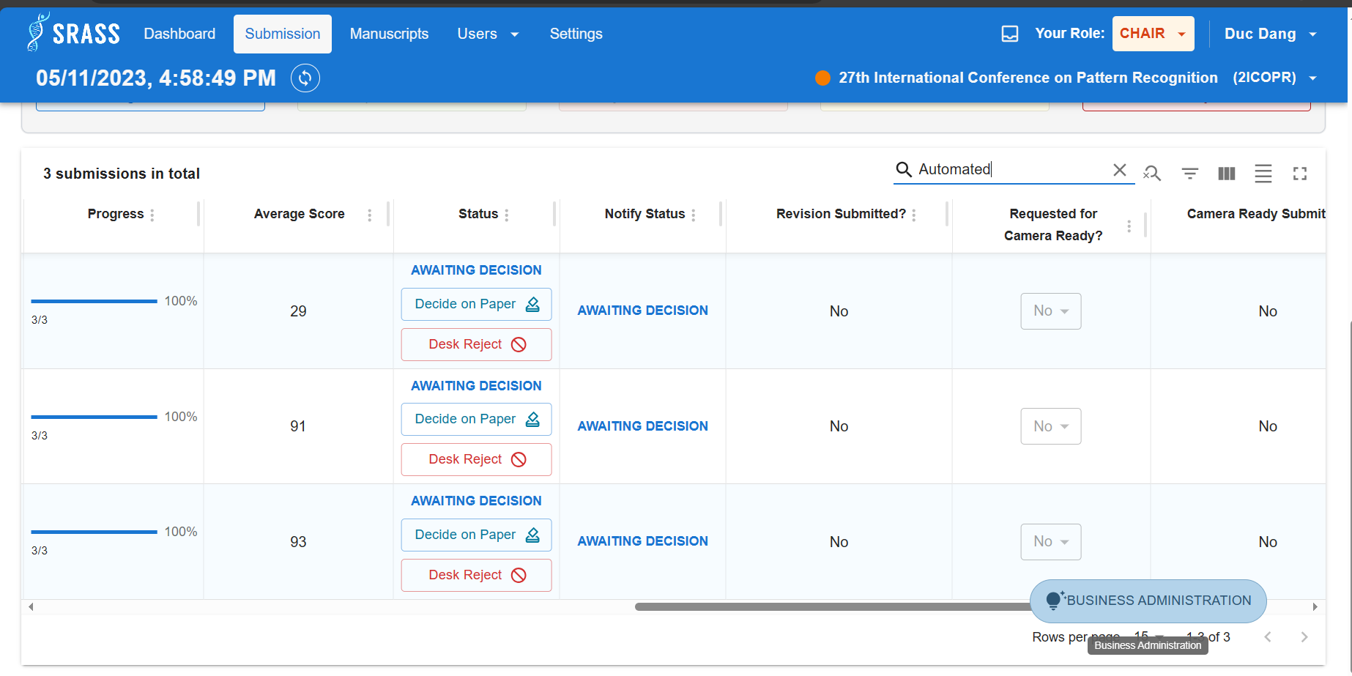 PC Chair can review all submission’s reviews before deciding.

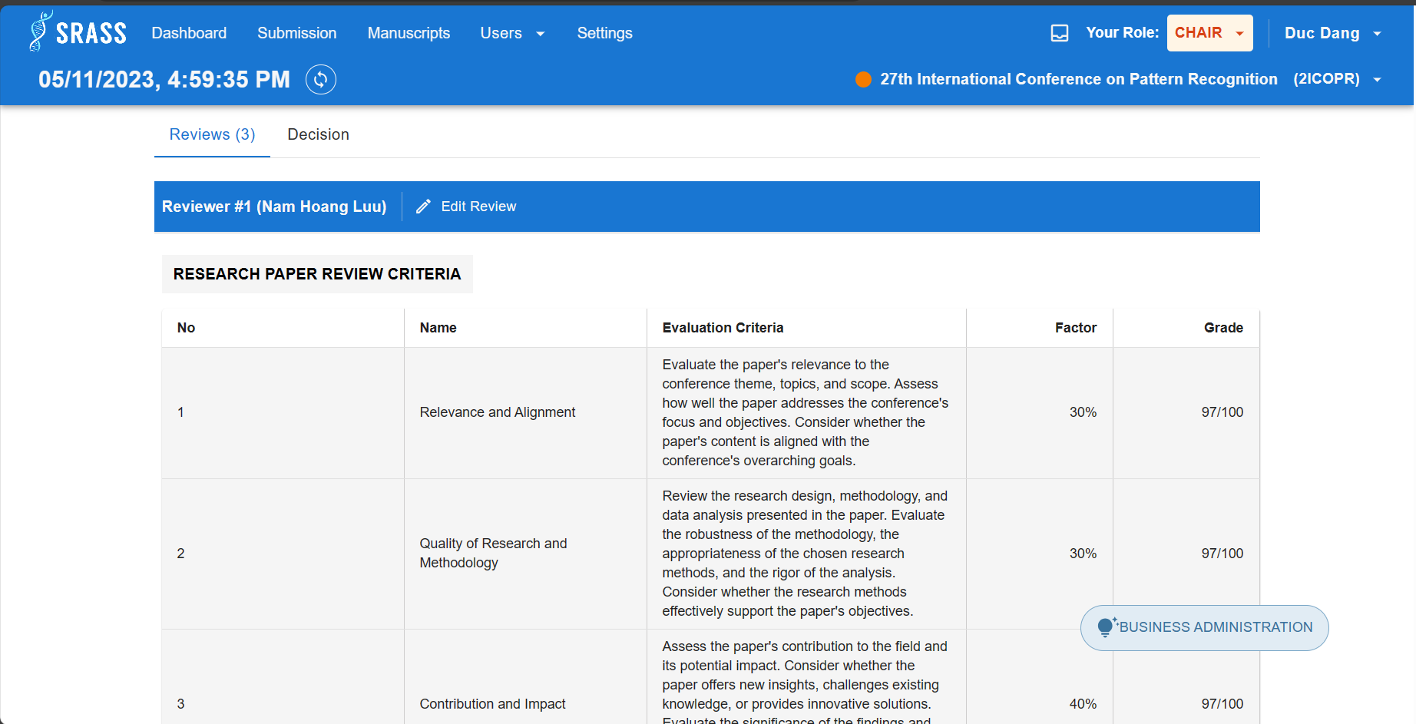 After reviewing, PC Chair check works to do and assign status for submission, then click ”Submit Decision” button to decide.

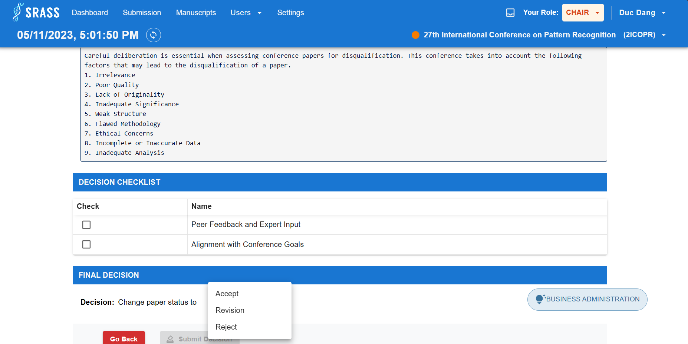 PC Chair can view statistic of decided submissions after deciding a list of submissions.

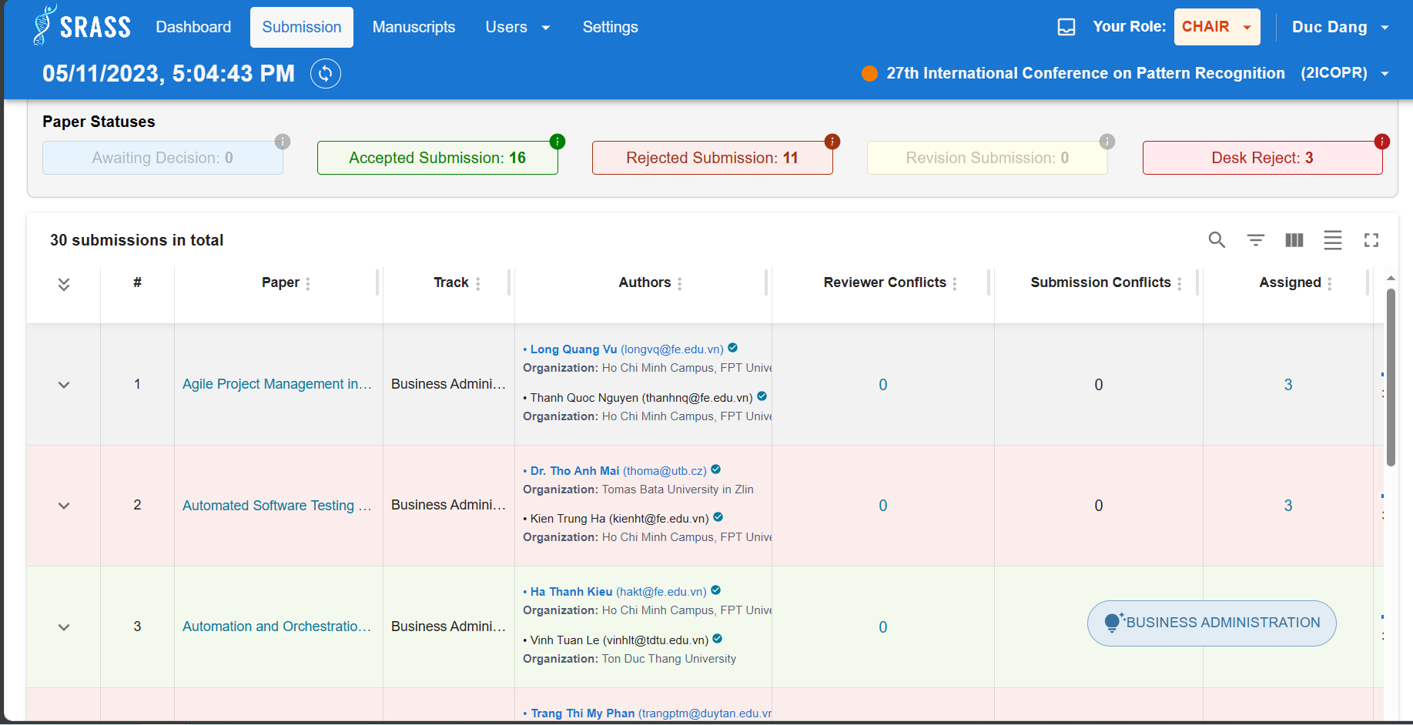 ***3.3.8 <PC Chair> Notify Status Of Submission To Authors***

To notify to Authors, PC Chair click on “Author Notification” button.

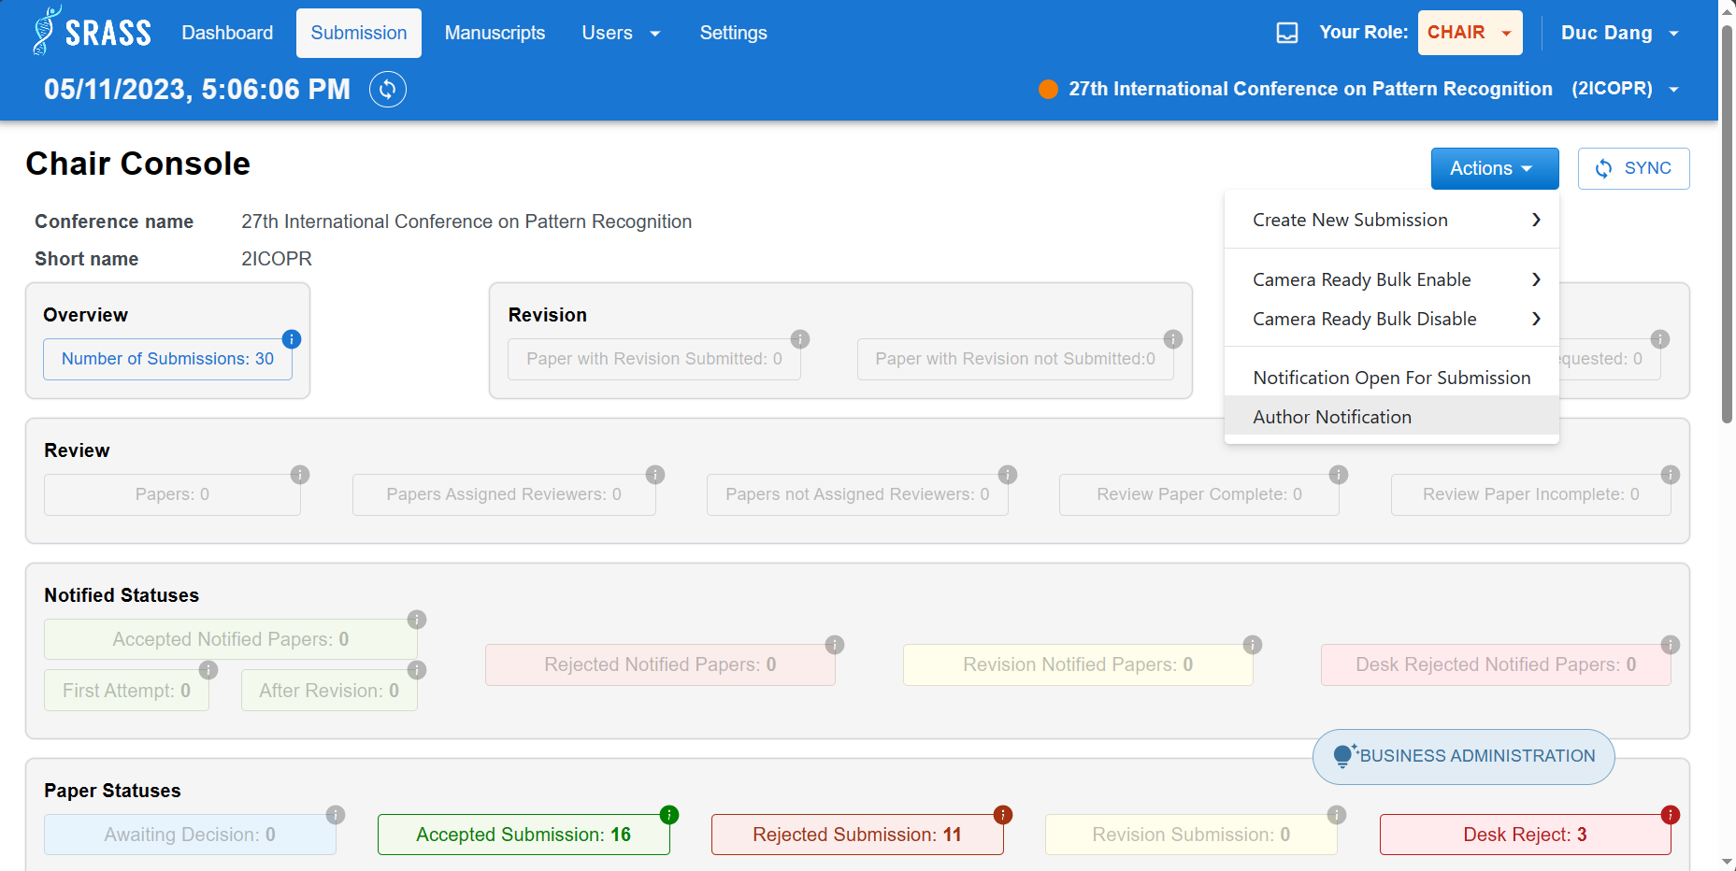 Select the track that want to notify and click ”Next” button to move on.

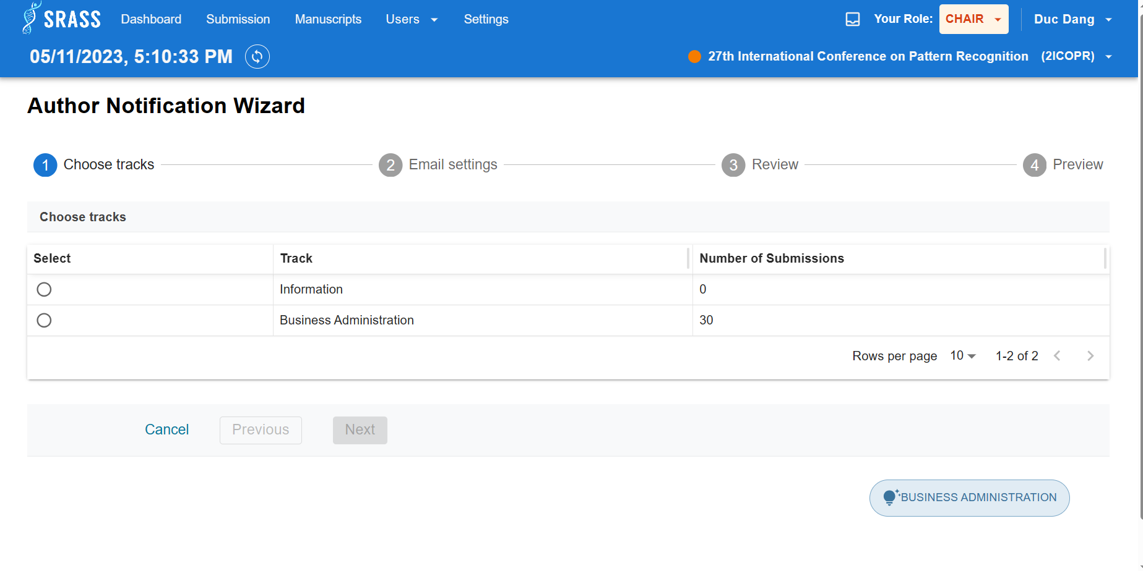 PC Chair must create email template for paper status before move on next step. To create email template, click on ”+ Create New Template” button. After that select email template suiting each paper status, then click on ”Next” button to move on.

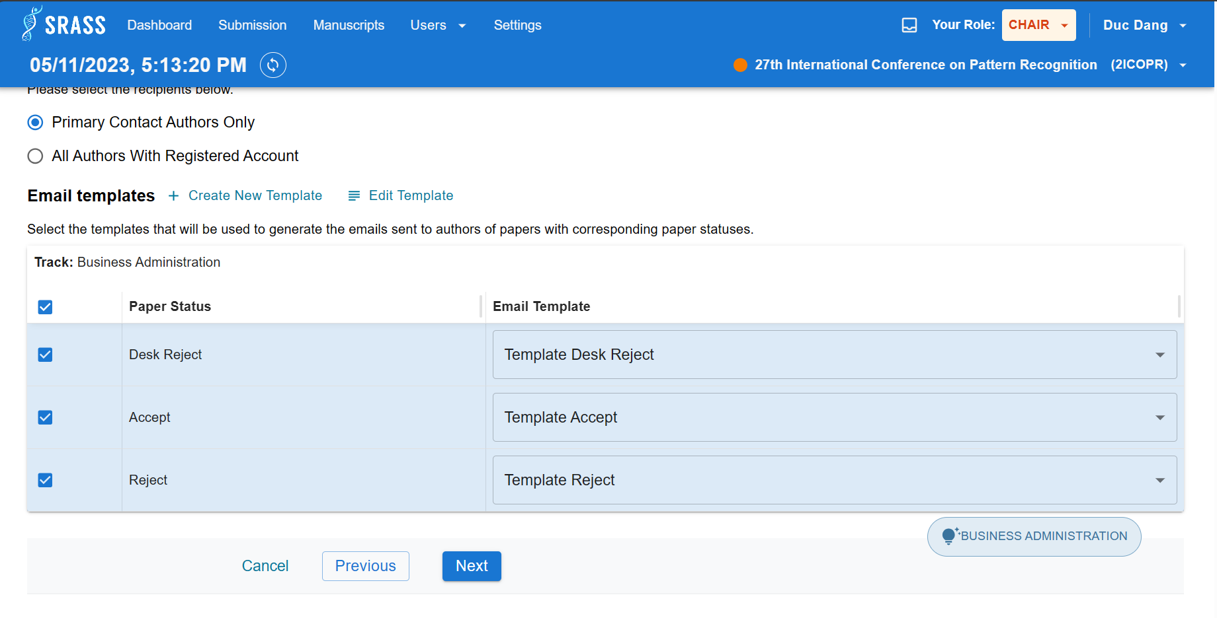 PC Chair can review statistic number of submission and number of emails to send. Click ”Next” button to move on.

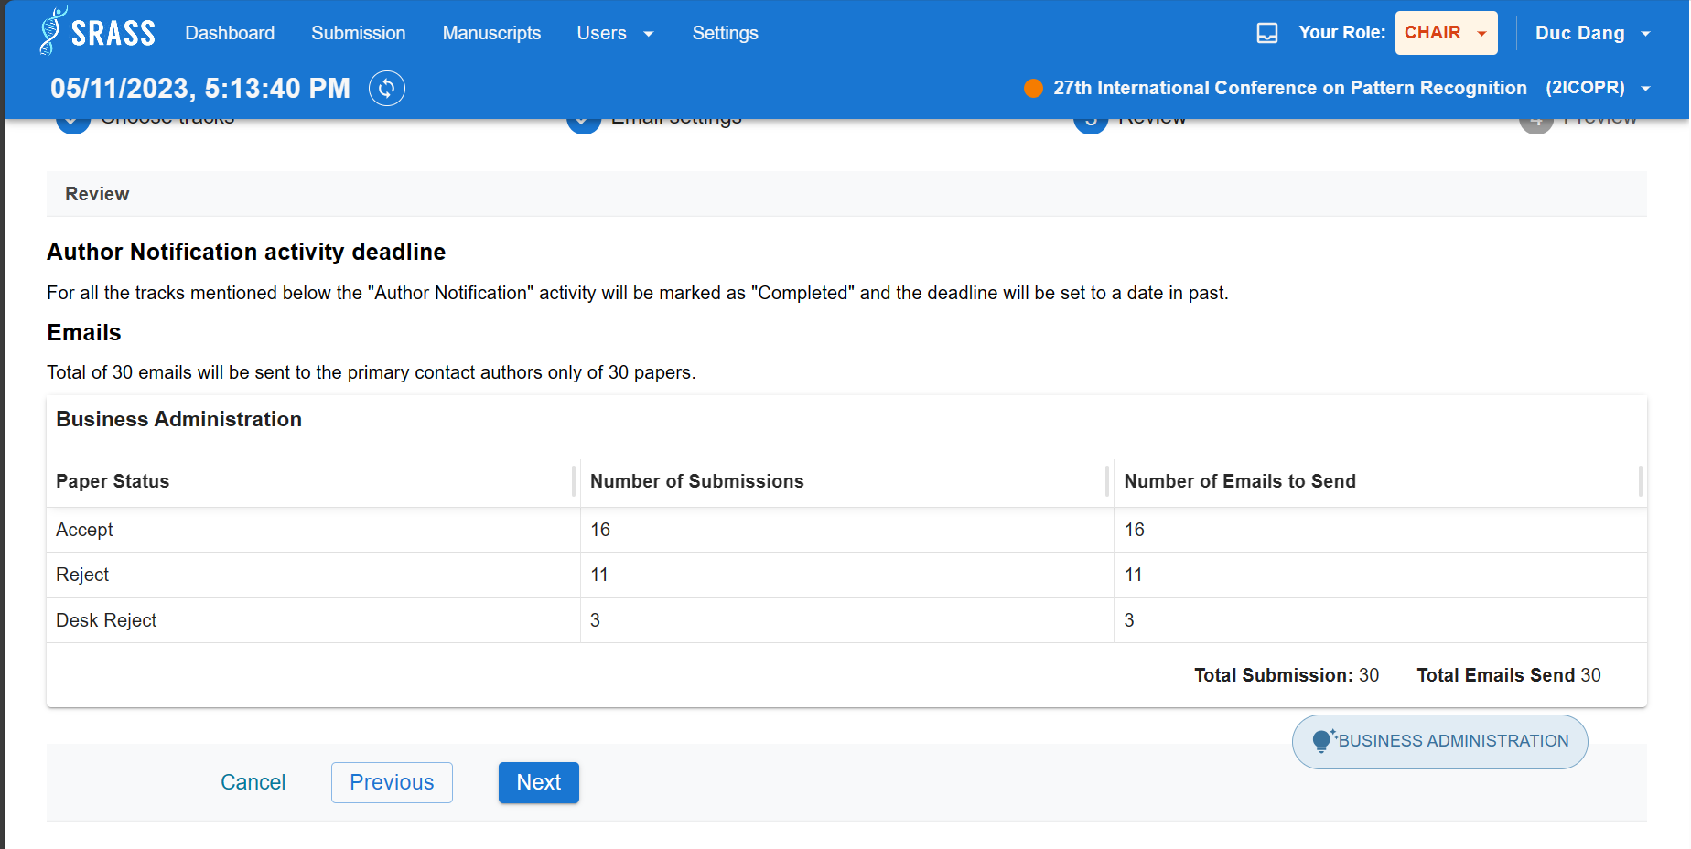 PC Chair can preview the content of email before sending by click on ”Eyes” icon. Then click no ”Send” button to send emails.

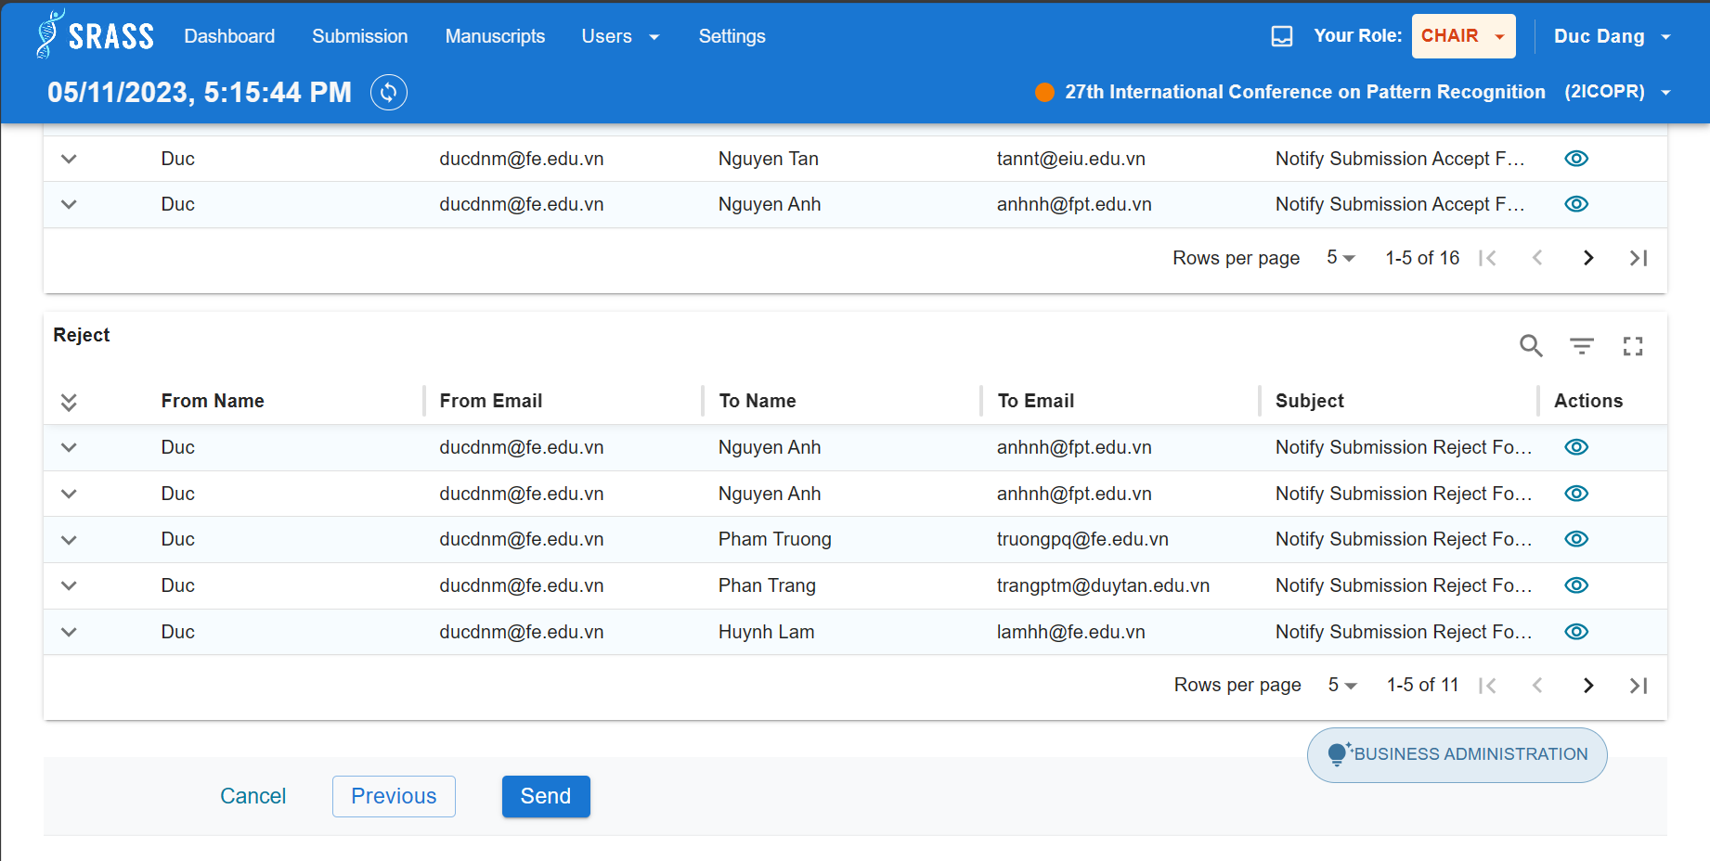 Before ”Open for Camera Ready Submission” phase. PC Chair must request camera ready for submissions. To request a bulk of submissions, PC Chair click on ”Camera Ready Bulk Enable” then choose track.

### 3.4 Workflow 3 - Prepare Conference Proceeding​

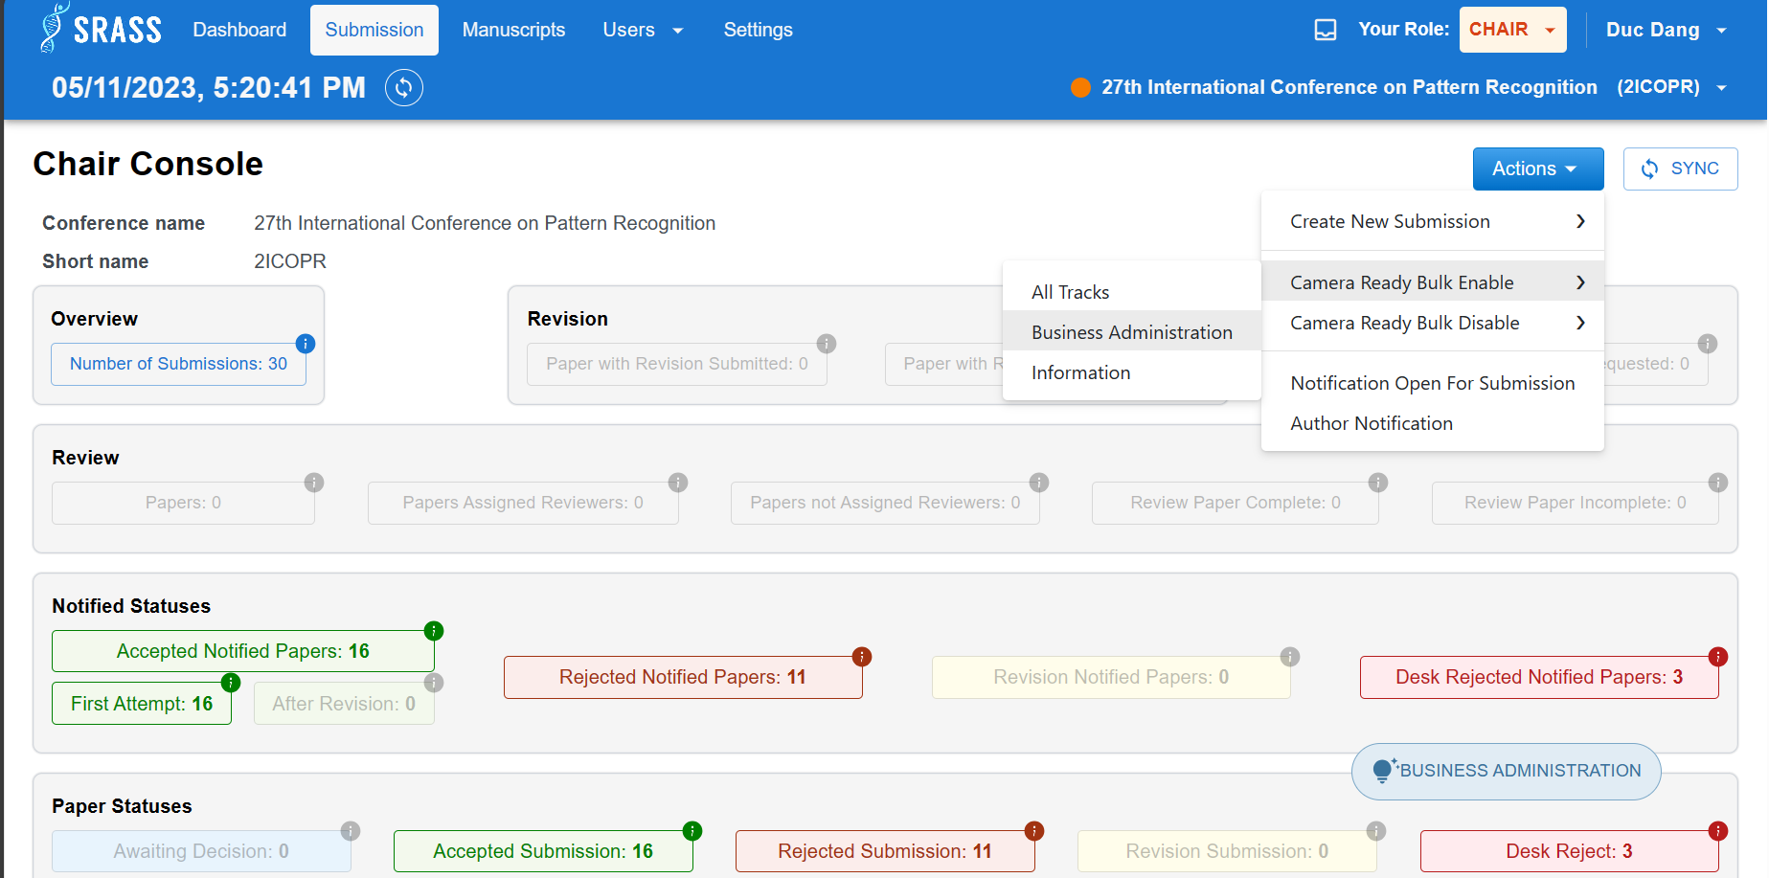

#### 3.4.1 <Author> Submit Camera Ready

The current phase of the conference is ”Open for Camera Ready Submission”. Author now can submit camera ready by clicking on “Create Camera Ready”.

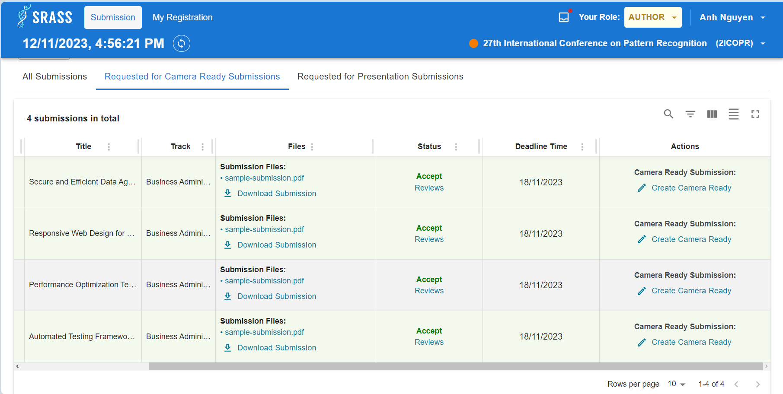 To create Camera Ready. Author must fulfil required information then click on ”+ Submit Camera Ready” to submit.

#### 3.4.2 <Author> Register Papers

After submitting camera ready, Author can register paper by clicking “REGISTER PAPER” button.

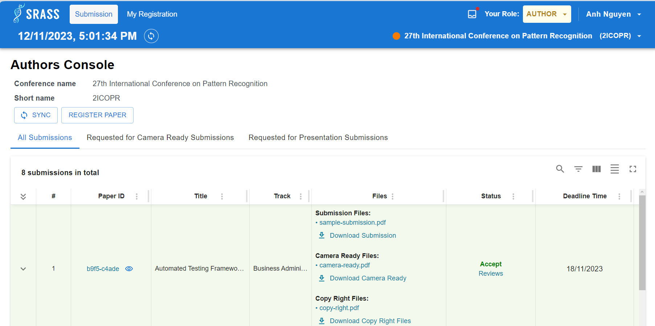

Registartion Papers maybe free or paid depending on how PC Chair configure the price. Author must choose option and select the paper to register. Then click on “CHECK OUT” button to move on.

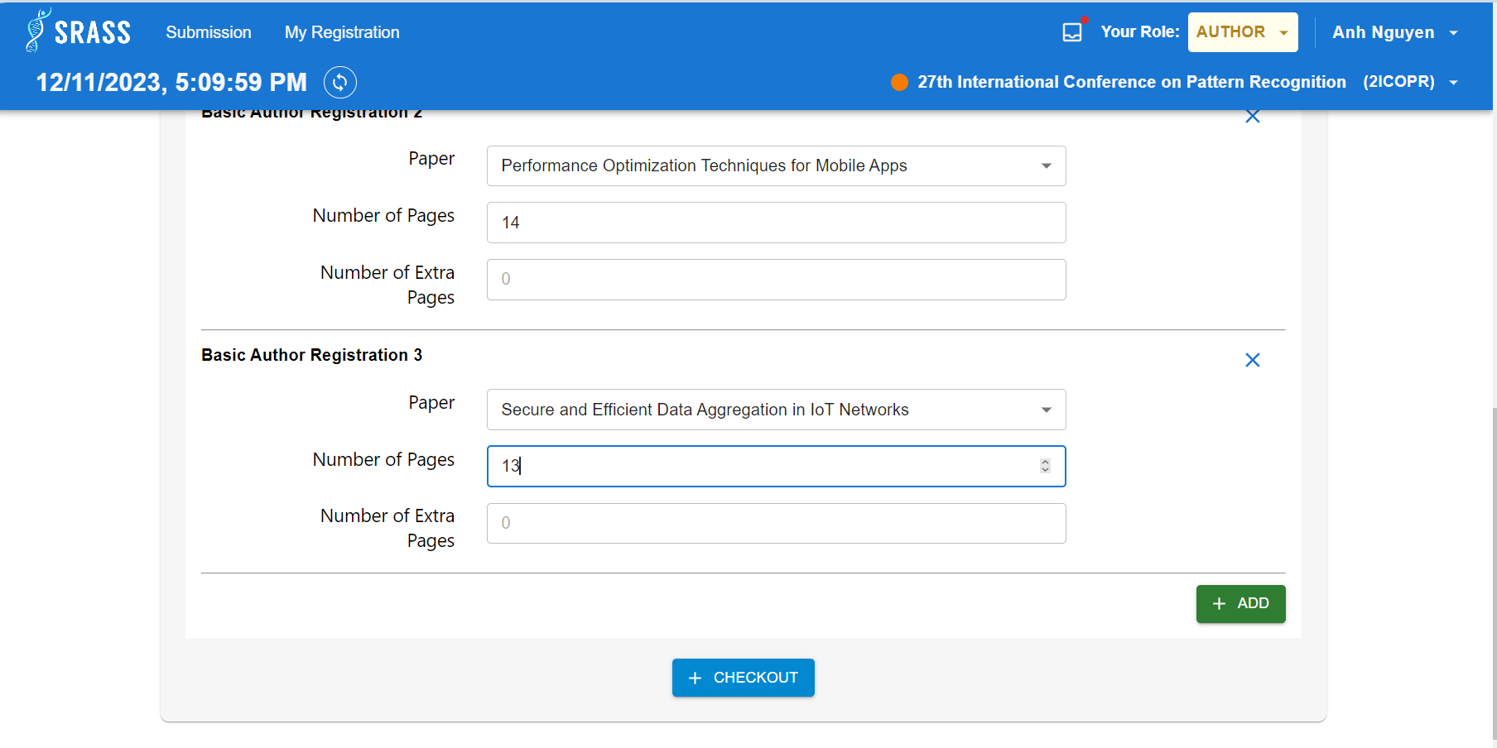 Author can view summary of information before finishing registration.

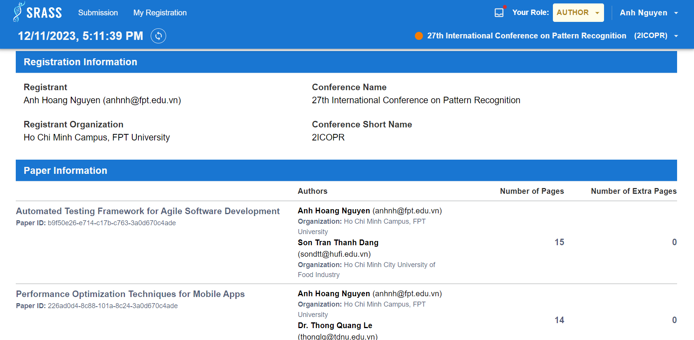

#### 3.4.3 <Author> Submit Presentation Submission

Before “Open for Presentation Submission” phase. PC Chair must request for presentations by clicking on “Presentation Bulk Enable” and choose track.

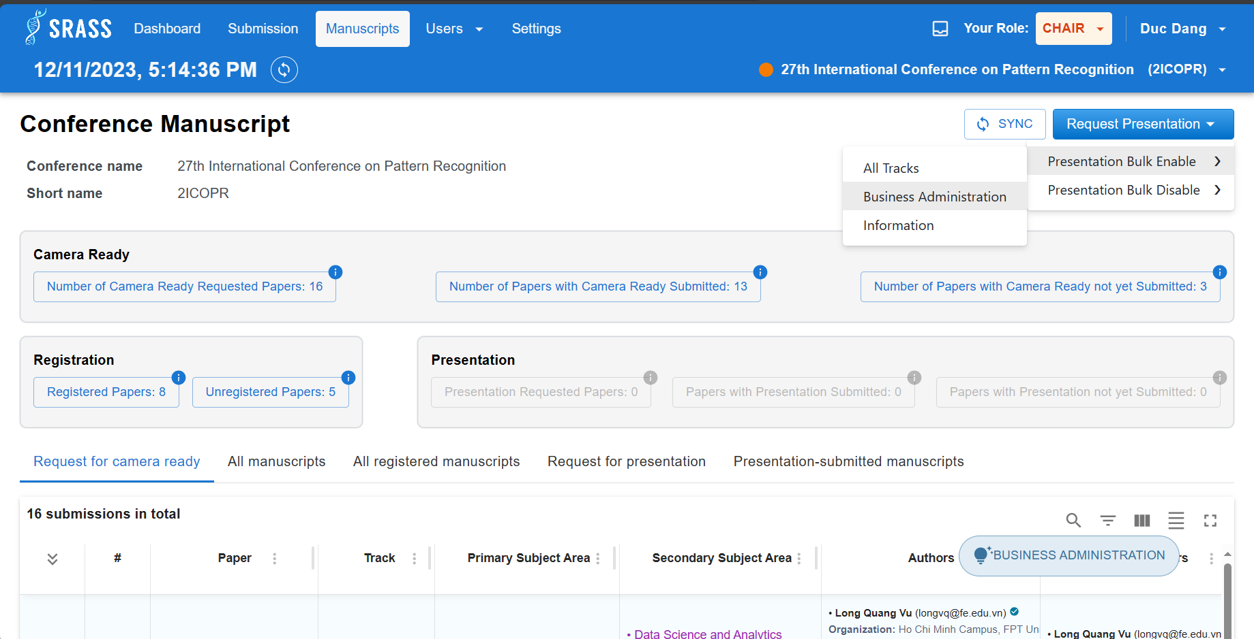

The current phase of the conference is ”Open for Presentation Submission”. Author now can submit camera ready by clicking on “Upload Presentation”.

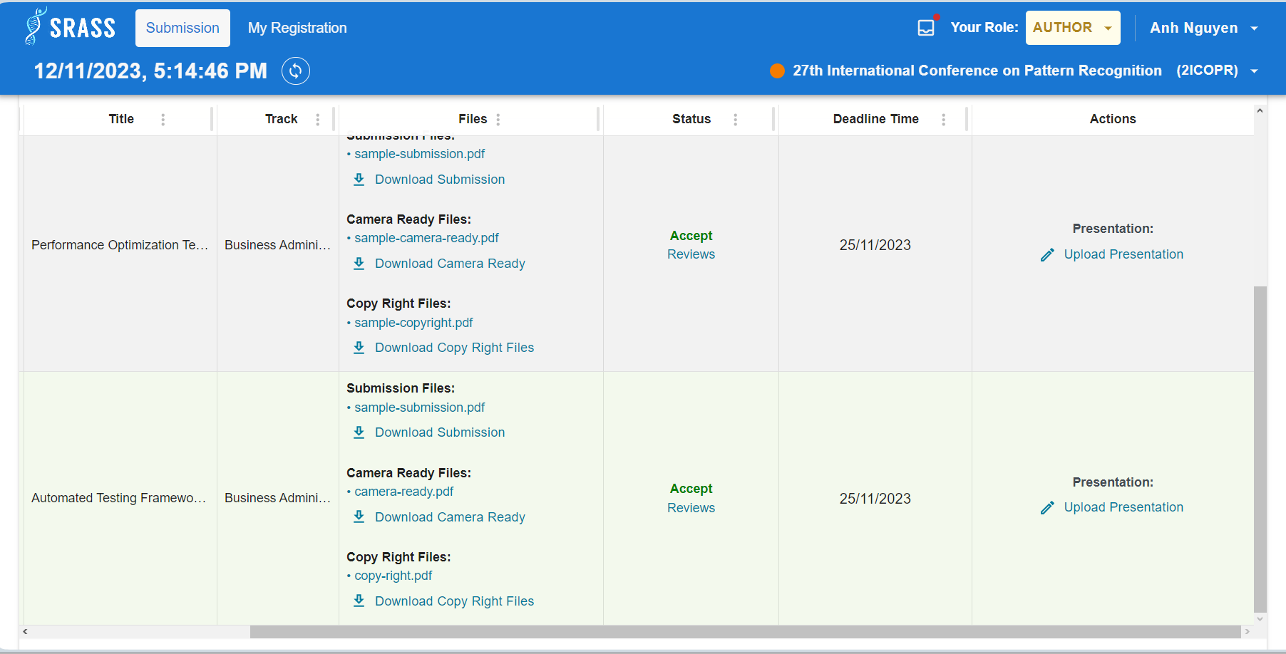

Author fulfils required information then click on “Upload Presentation” button to submit.

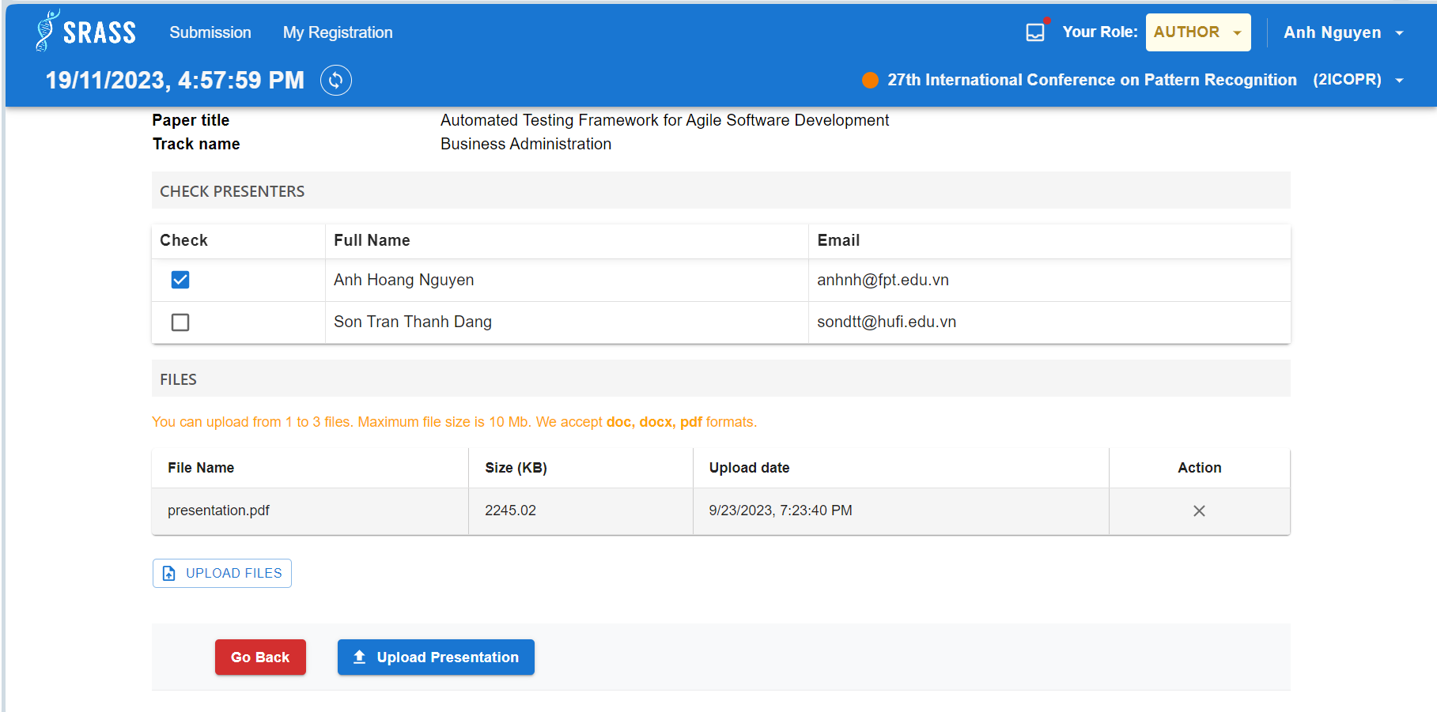

#### 3.4.4 <Admin> Export Final Report.

After the conference has ended, now Admin can export the final report by clicking on “EXPORT FINAL REPORT” button.

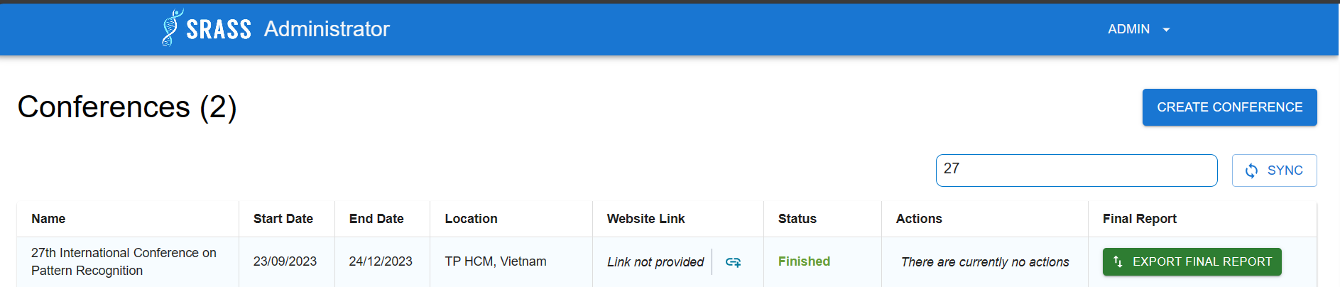

Here is the structure of final report

